Annexure – 1

**E – ATTENDANCE SYSTEM**

**A Project Work**

*Submitted in the partial fulfilment for the award of the degree of*

**BACHELOR OF ENGINEERING**

**IN**

**CSE (Hons.) with Specialisation in**

**ARTIFICIAL INTELLIGENCE and MACHINE LEARNING**

**submitted by:**

**DWAPOYAN ROY,**

**20BCS6043**

**Under the Supervision of:**

**Dr. Arun Mittal**



# DEPARTMENT OF COMPUTER SCIENCE AND ENGINEERING APEX INSTITUE OF TECHNOLOGY

**CHANDIGARH UNIVERSITY, GHARUAN, MOHALI - 140413, PUNJAB**

**MAY 2022**

Annexure – 2

**DECLARATION**

I, **‘ Dwapoyan Roy**, student of **‘Bachelor of Engineering in CSE (Hons.) with Specialisation in Artificial Intelligence and Machine Learning’**,

**session: 2020-2024**, Department of Computer Science and Engineering, Apex Institute of Technology, Chandigarh University, Punjab, hereby declare that the work presented in this Project Work entitled ‘**Face Recognition based E – Attendance System**’is the outcome of our own bona fide work and is correct to the best of our knowledge and this work has been undertaken taking care of Engineering Ethics. It contains no material previously published or written by another person nor material which has been accepted for the award of any other degree or diploma of the university or other institute of higher learning, except where due acknowledgment has been made in the text.

**Dwapoyan Roy**

**20bcs6043**

**Date: 23/05/2022**

**Place: Chandigarh University**

Annexure – 3

# Table of Contents

Title Page Annexure - 1

Declaration of the student Annexure - 2

Abstract Annexure - 2

Acknowledgement Annexure - 1

1. **INTRODUCTION 1**

1.1 Problem Definition 1

1.2 Project Overview/Specification*(page-1 and 3) 2

1.3 Hardware Specification 2

1.4 Software Specification 2

1. **LITERATURE SURVEY 3**

2.1 Existing System 3 2.2 Proposed System 4 2.3 Feasibility Study* (page – 4) 5

1. **PROBLEM FORMULATION 6**
2. **OBJECTIVES 6**
3. **METHODOLOGY 7**
4. **OUTPUT 55**
5. **REFERENCES 65**

#### **INTRODUCTION**

In today's competitive world, with increasing working hours and less classroom time, teachers need EdTech tools which help them manage precious class time efficiently. Instead of focusing on teaching, faculty members are often stuck with completing formal duties, for e.g., taking daily student attendance.

Manually taking attendance and registering it in files & musters makes the daily attendance a mundane task for the faculty and unnecessarily consumes classroom time.

To overcome such inefficient work processes, there are various school software systems available to speed up the attendance process and reduce manual work. An online attendance management system or digital attendance platform is one of them, which is developed to automate the daily attendance in schools. Additionally, it helps to maintain accurate records and generate summarized student attendance reports.

Attendance management system keeps track of daily attendance, working hours, breaks, login, and logout time. It prevents staff's time theft. An attendance management system integrates all attendance devices such as smart cards, biometric, and facial recognition devices in real-time.

MasterSoft's Student attendance management software allows schools of all sizes to manage various attendance requirements. This system makes it easy to create daily attendance reports, absentee lists, letters and other documents almost effortlessly. Student attendance system helps teachers to mark online attendance of students during class & reduce manual work. It is used to track student's attendance, absentee record, attendance history & other related documents. Student attendance software allows you to record & manage daily student attendance to speed up the daily attendance process.

Online attendance management system enables school administrators to record, manage & compile daily student attendance data. Along with student attendance, this software also allows teachers to generate 100% accurate student attendance reports.

**Purpose: -** The purpose of creating an attendance management system is to automate the traditional method of taking attendance. Another reason for designing this programme is to automatically generate the report at the end of the session or in the middle of it.

**Specifications:**

* 1. Uses LBPH (Local Binary Pattern Histogram) algorithm for face detection.
  2. Score of minimum 100 required to perfectly match a face.
  3. Metric: Camera Resolution.
  4. For prototype fixed to 15 users only but scalable design.
  5. Requires good lighting condition for better camera capture capability.
  6. Attendance sheet is .csv format and can be digitally distributed and maintained.

**Hardware used**: A laptop, OS: windows, system type: 64-bit operating system, x64-based processor, OS build: 22000.675

**Software’s used:** Anaconda Navigator,

Jupyter Notebook,

python3, OpenCV,

Microsoft Excel

Tkinter

#### **LITERATURE REVIEW**

Face recognition is one of the few biometric methods that possess the merits of both high accuracy and low intrusiveness. It has the accuracy of a physiological approach without being intrusive. Over past 30 years, many researchers have proposed different face recognition techniques, motivated by the increased number of real-world applications requiring the recognition of human faces. There are several problems that make automatic face recognition a very difficult task. However, the face image of a person inputs to the database that is usually acquired under different conditions. The important of automatic face recognition is much be cope with numerous variations of images of the same face due to changes in the following parameters such as 1. Pose, 2. Illumination, 3. Expression, 4. Motion, 5. Facial hair, 6. Glasses, 7. Background of image. Face recognition technology is well advance that can be applied for many commercial applications such as personal identification, security system, image- film processing, psychology, computer interaction, entertainment system, smart card, law enforcement, surveillance and so on. Face recognition can be done in both a still image and video sequence which has its origin in still-image face recognition. Different approaches of face recognition for still images can be categorized into three main groups such as 1. Holistic approach 2. Feature-based approach 3. Hybrid approach product.

1. Holistic approach: In holistic approach or global feature, the whole face region is taken into account as input data into face detection system. Examples of holistic methods are eigenfaces (most widely used method for face recognition), probabilistic eigenfaces, fisherfaces, support vector machines, nearest feature lines (NFL) and independent-component analysis approaches. They are all based on principal component-analysis (PCA) techniques that can be used to simplify a dataset into lower dimension while retaining the characteristics of dataset.

2. Feature In feature-based approach: based approaches or local feature that is the features on face such as nose, and then eyes are segmented and then used as input data for structural classifier. Pu re geometry, dynamic link architecture, and hidden Markov model methods belong to this category. One of the most successful of these systems is the Elastic Bunch Graph Matching (EBGM) system [40],[41], which is based on DLA. Wavelets, especially Gabor wa velets, play a building block role for facial representation in these graph matching methods. A typical local feature representation consists of wavelet coefficients for different scales and rotations based on fixed wavelet bases. These locally estimated wa velet coefficients are robust to illumination change, translation, distortion, rotation, and scaling. The grid is appropriately positioned over the image and is stored with each grid point’s locally determined jet in figure 2(a), and serves to represent the pattern classes. Recognition of a new image takes place by transforming the image into the grid of jets, and matching all stored model graphs to the image. Conformation of the DLA is done by establishing and dynamically modifying links between vertices in the model domain.

3. Hybrid approach: The idea of this method comes from how human vision system perceives both holistic and local feature. The key factors that influence the performance of hybrid approach include how to determine which features sho uld be combined and how to combine, so as to preserve their advantages and avert their disadvantages at the same time. These problems have close relationship with the multiple classifier system (MCS) and ensemble learning in the field of machine learning. Unfortunately, even in these fields, these problems remain unsolved. In spite of this, numerous efforts made in these fields indeed provide us some insights into solving these problems, and these lessons can be used as guidelines in designing a hybrid face recognition system. hybrid approach that use both holistic and local information for recognition may be an effective way to reduce the complexity of classifiers and improve their generalization capability.

Shirodkar M, et al. (2015) [41] proposed attendance administration device the use of the face focus method in which captured faces are matched with the face database of the students and mark attendance Sakshi, et al. Edelweiss Applied Science and Technology, 2021 Citation: Sakshi, Sharma C, Sharma S, Singh P and Khan AI. Advanced attendance management systems: applied sciences and applications (2021) Edelweiss Appli Sci Tech accordingly. Student photographs are captured in one-of-a-kind poses for the duration of the admission method and stored in the college database. Cameras are already established in the gadget which captures the solely frontal photograph of the pupil and matches captured image with the database if the image matches, then the device automatically mark the current for that precise student. Reports can be downloaded by means of the authorities at any time from the front end. The creator finished an accuracy of 83.2% from the proposed system. Jayant KN, et al. (2016) proposed attendance management system using hybrid face focus techniques. In this find out about writer set up excessive definition digital camera above the whiteboard of the type which capture all students three times in the total period of the class due to the fact of editions in the pose of the students. Viola-Jones algorithm is viewed via the writer for face detection in their learn about due to the quick feature resolution procedure. The machine will seize and manner statistics in three frames and the frame offers the very best detection charge that body will be considered through the gadget to mark the attendance in excel format.

#### **PROBLEM FORMULATION**

Attendance Management System is software developed for daily student attendance in schools, colleges and institutes. It facilitates to access the attendance information of a particular student in a particular class. This system will also help in evaluating attendance eligibility criteria of a student. By just a click on the mouse, the system will be able to produce the students' attendance report thus reducing the need for manual labour which is prone to human errors and time consuming.

This application is built for automating the processing of attendance. It also enhances the speed of performing attendance task easily.

#### **OBJECTIVES**

The "Attendance Management System" is a piece of software designed to track a student's attendance in college on a daily basis. The staff members in charge of the topics will be responsible for keeping track of the students' attendance. Each member of staff will be given a unique username and password based on the subject they are responsible for. This is where the accurate report based on student attendance is prepared. This approach will also assist in determining a student's attendance eligibility criteria. On a weekly and monthly basis, a report on the student's attendance is generated.

**User Friendly**: User interface is very easy. Data storing and recovery is fast and secured. In addition, application is provided with graphical representation for easier interpretation and analysis.

**Reports are Easily Generated**: Various reports, such as student-by-student attendance, day-by-day attendance, class-by-class attendance, month-by-month-by-month-by-month-by-month-by-month-by-month-by-month-by-month-by-month-by-month-by Instant access to current and historical reports is possible.

**Zero Risks**: There is no paperwork involved, and there is no possibility of human error when manually recording attendance.

#### **METHODOLOGY**

**ANACONDA**

Anaconda is a distribution of the Python and R programming languages for scientific computing (data science, computing device studying applications, large-scale facts processing, predictive analytics, etc.), that targets to simplify package administration and deployment. The distribution consists of data-science packages suitable for Windows, Linux, and macOS. It is developed and maintained via Anaconda, Inc.,

**Python**  
Python is often used as a support language for software program developers, for build manage and management, testing, and in many other ways. SCons for build control. Build Bot and Apache Gump for automated continuous compilation and testing. Roundup or Trac for bug monitoring and assignment management.

# 

# pandas

Pandas is an open-source library that is made mainly for working with relational or labelled data both easily and intuitively. It provides various data structures and operations for manipulating numerical data and time series. This library is built on top of the NumPy library. Pandas is fast and it has high performance & productivity for users.

## **Advantages**

* Fast and efficient for manipulating and analysing data.
* Data from different file objects can be loaded.
* Easy handling of missing data (represented as Nan) in floating point as well as non-floating-point data
* Size mutability: columns can be inserted and deleted from DataFrame and higher dimensional objects
* Data set merging and joining.
* Flexible reshaping and pivoting of data sets
* Provides time-series functionality.
* Powerful group by functionality for performing split-apply-combine operations on data sets.

**dlib**

The dlib library provides two functions that can be used for face detection:

1. **HOG + Linear SVM:**

dlib.get_frontal_face_detector()

1. **MMOD CNN:**

dlib.cnn_face_detection_model_v1(modelPath)

get_frontal_face_detector function does not accept any parameters. A call to it returns the pre-trained HOG + Linear SVM face detector included in the dlib library.

The Dlib’s HOG + Linear SVM face detector is fast and efficient. By nature of how the Histogram of Oriented Gradients (HOG) descriptor works, it is not invariant to changes in rotation and viewing angle.

For more robust face detection, you can use the MMOD CNN face detector, available via the cnn_face_detection_model_v1 function. This method accepts a single parameter, modelPath, which is the path to the pre-trained mmod_human_face_detector.dat file residing on disk.

**pip install click**

Click is a Python package for creating beautiful command line interfaces in a composable way with as little code as necessary. It’s the “Command Line Interface Creation Kit”. It’s highly configurable but comes with sensible defaults out of the box.

It aims to make the process of writing command line tools quick and fun while also preventing any frustration caused by the inability to implement an intended CLI API.

Click in three points:

* arbitrary nesting of commands
* automatic help page generation
* supports lazy loading of subcommands at runtime

**pip install cmake**

CMake is a cross-platform free and open-source software tool for managing the build process of software using a compiler-independent method. It supports directory hierarchies and applications that depend on multiple libraries.

**pip install Pillow**

Pillow is a Python Imaging Library (PIL), which adds support for opening, manipulating, and saving images. The current version identifies and reads a large number of formats. Write support is intentionally restricted to the most commonly used interchange and presentation formats

**pip install datetime**

A date in Python is not a data type of its own, but we can import a module named ‘datetime’ to work with dates as date objects.

import datetime  
  
x = datetime.datetime.now()  
  
print(x.year)  
print(x.strftime("%A"))

To create a date, we can use the datetime() class (constructor) of the datetime module.

The datetime() class requires three parameters to create a date: year, month, day.

**pip install pytest-shutil**

This library is a goodie-bag of Unix shell and environment management tools for automated tests. A summary of the available functions is below, look at the source for the full listing.

**pip install python-csv**

The so-called CSV (Comma Separated Values) format is the most common import and export format for spreadsheets and databases. CSV format was used for many years prior to attempts to describe the format in a standardized way in [**RFC 4180**](https://tools.ietf.org/html/rfc4180.html). The lack of a well-defined standard means that subtle differences often exist in the data produced and consumed by different applications. These differences can make it annoying to process CSV files from multiple sources. Still, while the delimiters and quoting characters vary, the overall format is similar enough that it is possible to write a single module which can efficiently manipulate such data, hiding the details of reading and writing the data from the programmer.

The [csv](https://docs.python.org/3/library/csv.html#module-csv) module implements classes to read and write tabular data in CSV format. It allows programmers to say, “write this data in the format preferred by Excel,” or “read data from this file which was generated by Excel,” without knowing the precise details of the CSV format used by Excel. Programmers can also describe the CSV formats understood by other applications or define their own special-purpose CSV formats.

**pip install numpy**

NumPy can be used to perform a wide variety of mathematical operations on arrays. It adds powerful data structures to Python that guarantee efficient calculations with arrays and matrices and it supplies an enormous library of high-level mathematical functions that operate on these arrays and matrices.

**Face recognition**

The face recognition library, created by Adam Geitgey, wraps around dlib’s facial recognition functionality, and this library is super easy to work with and we will be using this in our code. Remember to install dlib library first before you install face recognition.

There are various types of face recognition algorithms, for example:

* Eigenfaces (1991)
* Local Binary Patterns Histograms (LBPH) (1996)
* Fisherfaces (1997)
* Scale Invariant Feature Transform (SIFT) (1999)
* Speed Up Robust Features (SURF) (2006)

### **1. Face Detection:**

The first task that we perform is detecting faces in the image(photograph) or video stream. Now we know that the exact coordinates/location of the face, so we extract this face for further processing.

### **2. Feature Extraction**:

Now see we have cropped out the face from the image, so we extract specific features from it. Here we are going to see how to use face embeddings to extract these features of the face. As we know a neural network takes an image of the face of the person as input and outputs a vector that represents the most important features of a face! In machine learning, this vector is nothing but called embedding and hence we call this vectorface embedding**.** Now how this will help in recognizing the faces of different people?

When we train the neural network, the network learns to output similar vectors for faces that look similar. Let us consider an example, if I have multiple images of faces within different timelapse, it’s obvious that some features may change but not too much. So, in this problem, the vectors associated with the faces are similar or we can say they are very close in the vector space.

Up to this point, we came to know how this network works, let us see how to use this network on our own data. Here we pass all the images in our data to this pre-trained network to get the respective embeddings and save these embeddings in a file for the next step.

### **3. Comparing Faces:**

We have face embeddings for each face in our data saved in a file, the next step is to recognize a new image that is not in our data. Hence the first step is to compute the face embedding for the image using the same network we used earlier and then compare this embedding with the rest of the embeddings that we have. We recognize the face if the generated embedding is closer or similar to any other embedding.

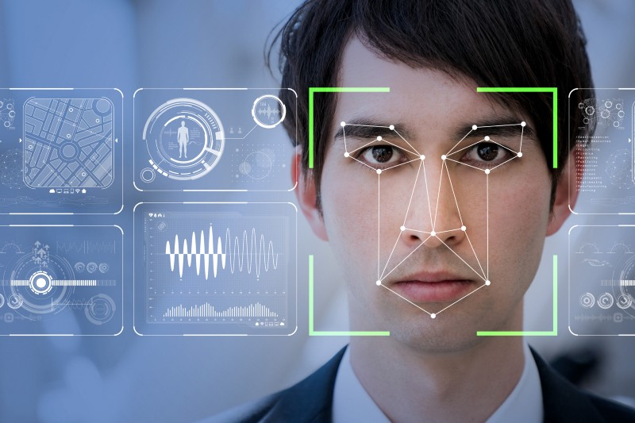

Nowadays, various packages are available to perform machine learning, deep learning, and computer vision problems. So far, computer vision is the best module for such complex problems. ***OpenCV*** is an open-source library. It is supported by different programming languages such as R, Python, etc. It runs probably on most platforms such as Windows, Linux, and macOS.

## Advantages of OpenCV:

1. Open CV is free of cost and an open-source library.

2. Open CV is fast as it is written in C/C++ language as compared to others

3. With less system RAM, OpenCV works better.

4. It supports most of the operating systems like Windows, Linux, and macOS.

## **Implementation**

In this section, we are going to implement face recognition using OpenCV and Python.

First, let us see what libraries we will need and how to install them:

1. OpenCV

2. dlib

3. Face_recognition

## **OpenCV**

OpenCV is the most popular library for computer vision. Originally written in C/C++, it now provides bindings for Python.

OpenCV uses machine mastering algorithms to search for faces inside a picture. Because faces are so complicated, there isn’t one easy take a look at that will tell you if it observed a face or not. Instead, there are thousands of small patterns and aspects that ought to be matched. The algorithms smash the task of figuring out the face into heaps of smaller, bite-sized tasks, each of which is effortless to solve. These tasks are additionally called classifiers.

**dlib**

The **dlib** library contains our implementation of ‘deep metric learning’ which is used to construct our face embeddings used for the actual recognition process.

**face recognition**

The **face_recognition** library is super easy to work with and we will be using this in our code. First, remember to install dlib library before you install face_recognition.

## **HAAR-Cascade Detection in OpenCV**

OpenCV provides the trainer as well as the detector. We can train the classifier for any object like cars, planes, and buildings by using the OpenCV. There are two primary states of the cascade image classifier first one is training and the other is detection.

OpenCV provides two applications to train cascade classifier **opencv_haartraining** and **opencv_traincascade**. These two applications store the classifier in the different file format.

For training, we need a set of samples. There are two types of samples:

* **Negative sample:** It is related to non-object images.
* **Positive samples:** It is a related image with detect objects.

A set of negative samples must be prepared manually, whereas the collection of positive samples is created using the **opencv_createsamples** utility.

### **Negative Sample**

Negative samples are taken from arbitrary images. Negative samples are added in a text file. Each line of the file contains an image filename (relative to the directory of the description file) of the negative sample. This file must be created manually. Defined images may be of different sizes.

### **Positive Sample**

Positive samples are created by opencv_createsamples utility. These samples can be created from a single image with an object or from an earlier collection. It is important to remember that we require a large dataset of positive samples before you give it to the mentioned utility because it only applies the perspective transformation.

**Step - 1**

First, we need to load the necessary XML classifiers and load input images (or video) in grayscale mode.

**Step -2**

After converting the image into grayscale, we can do the image manipulation where the image can be resized, cropped, blurred, and sharpen if required. The next step is image segmentation; identify the multiple objects in the single image, so the classifier quickly detects the objects and faces in the picture.

**Step - 3**

The haar-Like feature algorithm is used to find the location of the human faces in frame or image. All the Human faces have some common universal properties of faces like the eye region is darker than its neighbour’s pixels and nose region is more bright than the eye region.

**Step -4**

In this step, we extract the features from the image, with the help of edge detection, line detection, and centre detection. Then provide the coordinate of x, y, w, h, which makes a rectangle box in the picture to show the location of the face. It can make a rectangle box in the desired area where it detects the face.

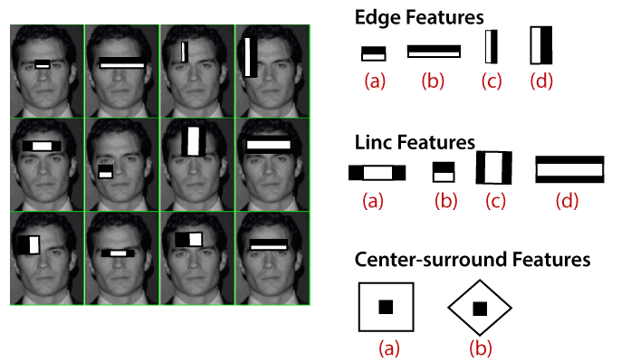

## **Introduction of LBPH**

**Local Binary Pattern Histogram algorithm** is a simple approach that labels the pixels of the image thresholding the neighbourhood of each pixel. In other words, LBPH summarizes the local structure in an image by comparing each pixel with its neighbours and the result is converted into a binary number. It was first defined in 1994 (LBP) and since that time it has been found to be a powerful algorithm for texture classification.

This algorithm is generally focused on extracting local features from images. The basic idea is not to look at the whole image as a high-dimension vector; it only focuses on the local features of an object.

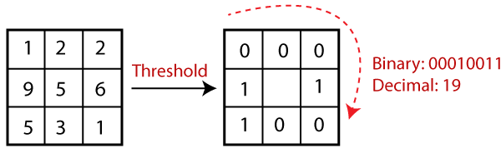

In the above image, take a pixel as centre and threshold its neighbour against. If the intensity of the centre pixel is greater-equal to its neighbour, then denote it with 1 and if not then denote it with 0.

Let's understand the steps of the algorithm:

**1. Selecting the Parameters:** The LBPH accepts the four parameters:

* **Radius:** It represents the radius around the central pixel. It is usually set to 1. It is used to build the circular local binary pattern.
* **Neighbour:** The number of sample points to build the circular binary pattern.
* **Grid X:** The number of cells in the horizontal direction. The more cells and finer grid represent, the higher dimensionality of the resulting feature vector.
* **Grid Y:** The number of cells in the vertical direction. The more cells and finer grid represent, the higher dimensionality of the resulting feature vector.

#### Note:**The above parameters are slightly confusing. It will be clearer in further steps.**

**2. Training the Algorithm:** The first step is to train the algorithm. It requires a dataset with the facial images of the person that we want to recognize. A unique ID (it may be a number or name of the person) should provide with each image. Then the algorithm uses this information to recognize an input image and give you the output. An Image of particular person must have the same ID. Let's understand the LBPH computational in the next step.

**3. Using the LBP operation:** In this step, LBP computation is used to create an intermediate image that describes the original image in a specific way through highlighting the facial characteristic. The parameters **radius** and **neighbour** are used in the concept of sliding window.

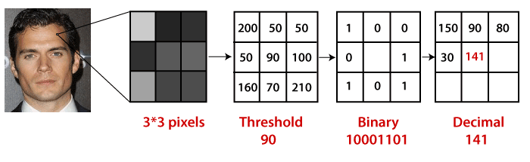

To understand in a more specific way, let's break it into several small steps:

* Suppose the input facial image is grayscale.
* We can get part of this image as a window of 3x3 pixels.
* We can use the 3x3 matrix containing the intensity of each pixel (0-255).
* Then, we need to take the central value of the matrix to be used as a threshold.
* This value will be used to define the new values from the 8 neighbours.
* For every neighbour of the central value (threshold), we set a new binary value. The value 1 is set for equal or higher than the threshold and 0 for values lower than the threshold.
* Now the matrix will consist of only binary values (skip the central value). We need to take care of each binary value from each position from the matrix line by line into new binary values (10001101). There are other approaches to concatenate the binary values (clockwise direction), but the final result will be the same.
* We convert this binary value to decimal value and set it to the central value of the matrix, which is a pixel from the original image.
* After completing the LBP procedure, we get the new image, which represents better characteristics of the original image.

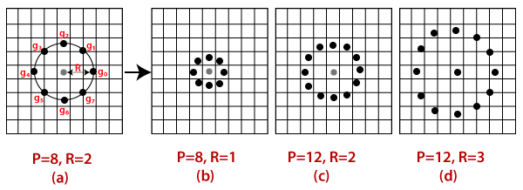

**4. Extracting the Histograms from the image:** The image is generated in the last step, we can use the **Grid X** and **Grid Y** parameters to divide the image into multiple grids, let's consider the following image:

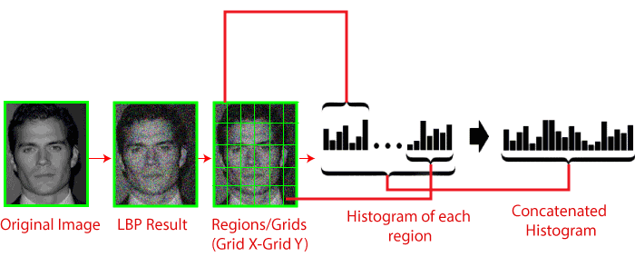

* We have an image in grayscale; each histogram (from each grid) will contain only 256 positions representing the occurrence of each pixel intensity.
* It is required to create a new bigger histogram by concatenating each histogram.

**5. Performing face recognition:** Now, the algorithm is well trained. The extracted histogram is used to represent each image from the training dataset. For the new image, we perform steps again and create a new histogram. To find the image that matches the given image, we just need to match two histograms and return the image with the closest histogram.

* There are various approaches to compare the histograms (calculate the distance between two histograms), for example: **Euclidean distance, chi-square, absolute value,** etc. We can use the Euclidean distance based on the following formula:

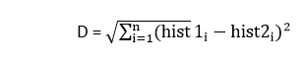

* The algorithm will return ID as an output from the image with the closest histogram. The algorithm should also return the calculated distance that can be called **confidence** measurement. If the confidence is lower than the threshold value, that means the algorithm has successfully recognized the face.

The Face Recognition Algorithm Input: A person’s face. Output: Attendance is marked for recognized faces. Initialization

1. Open the camera cv2.VideoCapture(0)

2. Import the face classifier LBPHFaceRecognizer_create()

3. Read the trained data from the file recognizer.read('trainer.yml') GPU Part

a. Image is captured frame by frame img = cap.read()

b. Face in the frame is converted to greyscale gray = (img, cv2.COLOR_BGR2GRAY)

c. All faces are detected in the frame faces = face_cas.detectMultiScale()

4. for coordinates of face: 1) values inside frame are read roi_gray = gray[y:y + h, x:x + w] 2) values are compared with stored values confidence = recognizer.predict(roi_gray)

5. if confidence<85: face matching with the values is recognized attendance is marked dataEntry(name,class_count)

6. else: face is not recognized id = 'Unknown' B.

Processes involved

**1. Pre-Processing Images** The system captures around 50 images of every individual’s face. The images are converted into grey scale as LBPH operates using images in greyscale and the images are stored in a folder. The stored images will be saved with a name and ID unique to that person.

**2. Face Detection** When a person appears in front of the camera, the camera detects that a face is present and a frame appears around the face. The entire frame is converted to greyscale as LBPH works only on greyscale images.

1) Eigen face

i. This algorithm extracts the necessary information from an image and efficiently encodes it.

ii. To obtain variations, a number of pictures of a single person is taken.

iii. For the set of images of faces, eigenvectors and its covariance matric is calculated and stored.

iv. Since every image represents an eigen vector, the data set helps produce variety for the system.

v. A representation of these eigen vectors is called eigen faces.

2) Line Edge Map

i. One of the popular methods is using the Line Edge Maps algorithm.

ii. In this method line matching is done to map the features of the face.

iii. This algorithm mainly uses the most prominent features of the face; mainly the eyes, nose and mouth having high characteristics.

iv. The colour images are converted to greyscale to observe and extract the similarities in the faces.

v. Sobel edge detection algorithm is made use of to encode the greyscale images into binary edge maps.

vi. This technique was developed by studying how we human beings remember others people’s faces (remembering face’s prominent features)

3) Histogram of oriented gradients (HOG)

i. This technique can be applied to detecting objects as well as faces.

ii. All images used are converted to greyscale and every pixel in this image in assigned an integer.

iii. Every pixel compares its value to its neighbouring pixels.

iv. The primary motive is to find the dark regions of the face in the image.

v. The direction pointing to that dark region will have a white arrow pointing towards it.

vi. This treatment is done for each pixel of the picture.

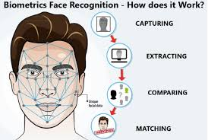

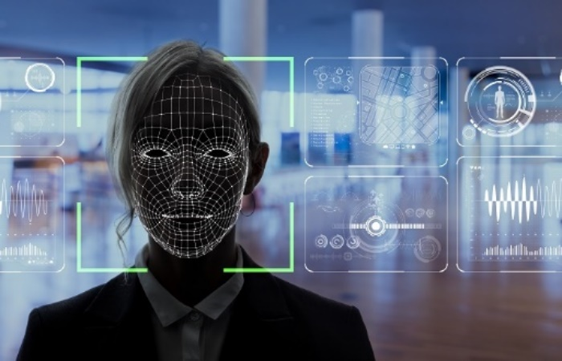

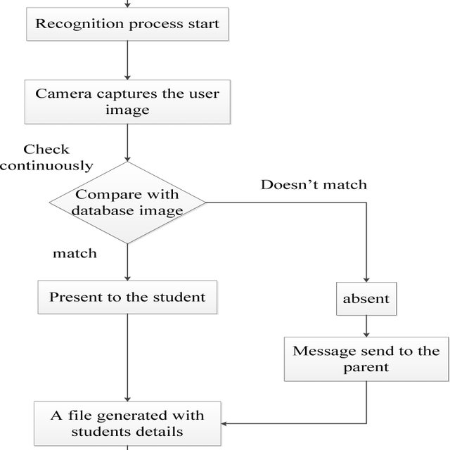

**Python GUI – Tkinter**

Python offers multiple options for developing GUI (Graphical User Interface). Out of all the GUI methods, tkinter is the most commonly used method. It is a standard Python interface to the Tk GUI toolkit shipped with Python. Python with tkinter is the fastest and easiest way to create the GUI applications. Creating a GUI using tkinter is an easy task.

**To create a tkinter app:**

1. Importing the module – tkinter
2. Create the main window (container)
3. Add any number of widgets to the main window
4. Apply the event Trigger on the widgets.

Importing tkinter is same as importing any other module in the Python code. Note that the name of the module in Python 2.x is ‘Tkinter’ and in Python 3.x it is ‘tkinter’.

import tkinter

There are two main methods used which the user needs to remember while creating the Python application with GUI.

1. **Tk(screenName=None,  baseName=None,  className=’Tk’,  useTk=1):**

To create a main window, tkinter offers a method ‘Tk(screenName=None,  baseName=None,  className=’Tk’,  useTk=1)’. To change the name of the window, you can change the className to the desired one. The basic code used to create the main window of the application is:

m=tkinter.Tk() where m is the name of the main window object

1. **mainloop():** There is a method known by the name mainloop() is used when your application is ready to run. mainloop() is an infinite loop used to run the application, wait for an event to occur and process the event as long as the window is not closed.

m.mainloop()

|  |
| --- |
| **import** tkinter  m **=** tkinter.Tk()  m.mainloop() |

tkinter also offers access to the geometric configuration of the widgets which can organize the widgets in the parent windows. There are mainly three geometry manager classes class.

1. **pack() method:** It organizes the widgets in blocks before placing in the parent widget.
2. **grid() method:** It organizes the widgets in grid (table-like structure) before placing in the parent widget.
3. **place() method:** It organizes the widgets by placing them on specific positions directed by the programmer.

There are a number of widgets which you can put in your tkinter application. Some of the major widgets are explained below:

1. Button: To add a button in your application, this widget is used.  
   The general syntax is:

w=Button(master, option=value)

master is the parameter used to represent the parent window.  
There are number of options which are used to change the format of the Buttons. Number of options can be passed as parameters separated by commas. Some of them are listed below.

* + **activebackground**: to set the background color when button is under the cursor.
  + **activeforeground**: to set the foreground color when button is under the cursor.
  + **bg**: to set he normal background color.
  + **command**: to call a function.
  + **font**: to set the font on the button label.
  + **image**: to set the image on the button.
  + **width**: to set the width of the button.
  + **height**: to set the height of the button.

|  |
| --- |
| **import** tkinter as tk  r **=** tk.Tk()  r.title('Counting Seconds')  button **=** tk.Button(r, text**=**'Stop', width**=**25, command**=**r.destroy)  button.pack()  r.mainloop() |

Output:  
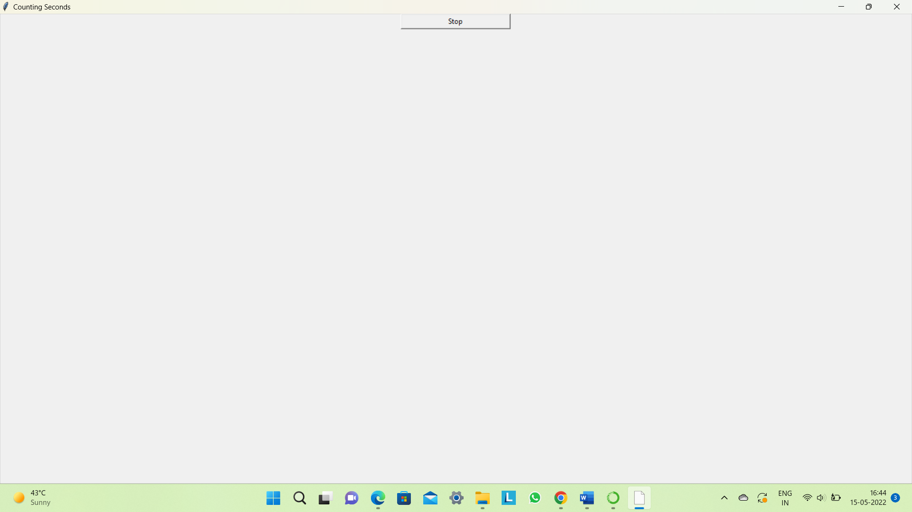

1. **Canvas:**It is used to draw pictures and other complex layout like graphics, text and widgets.  
   The general syntax is:

w = Canvas(master, option=value)

master is the parameter used to represent the parent window.

There are number of options which are used to change the format of the widget. Number of options can be passed as parameters separated by commas. Some of them are listed below.

* + **bd**: to set the border width in pixels.
  + **bg**: to set the normal background color.
  + **cursor**: to set the cursor used in the canvas.
  + **highlightcolor**: to set the color shown in the focus highlight.
  + **width**: to set the width of the widget.
  + **height**: to set the height of the widget.

|  |
| --- |
| **from** tkinter **import** **\***  master **=** Tk()  w **=** Canvas(master, width**=**40, height**=**60)  w.pack()  canvas_height**=**20  canvas_width**=**200  y **=** int(canvas_height **/** 2)  w.create_line(0, y, canvas_width, y )  mainloop() |

Output:  
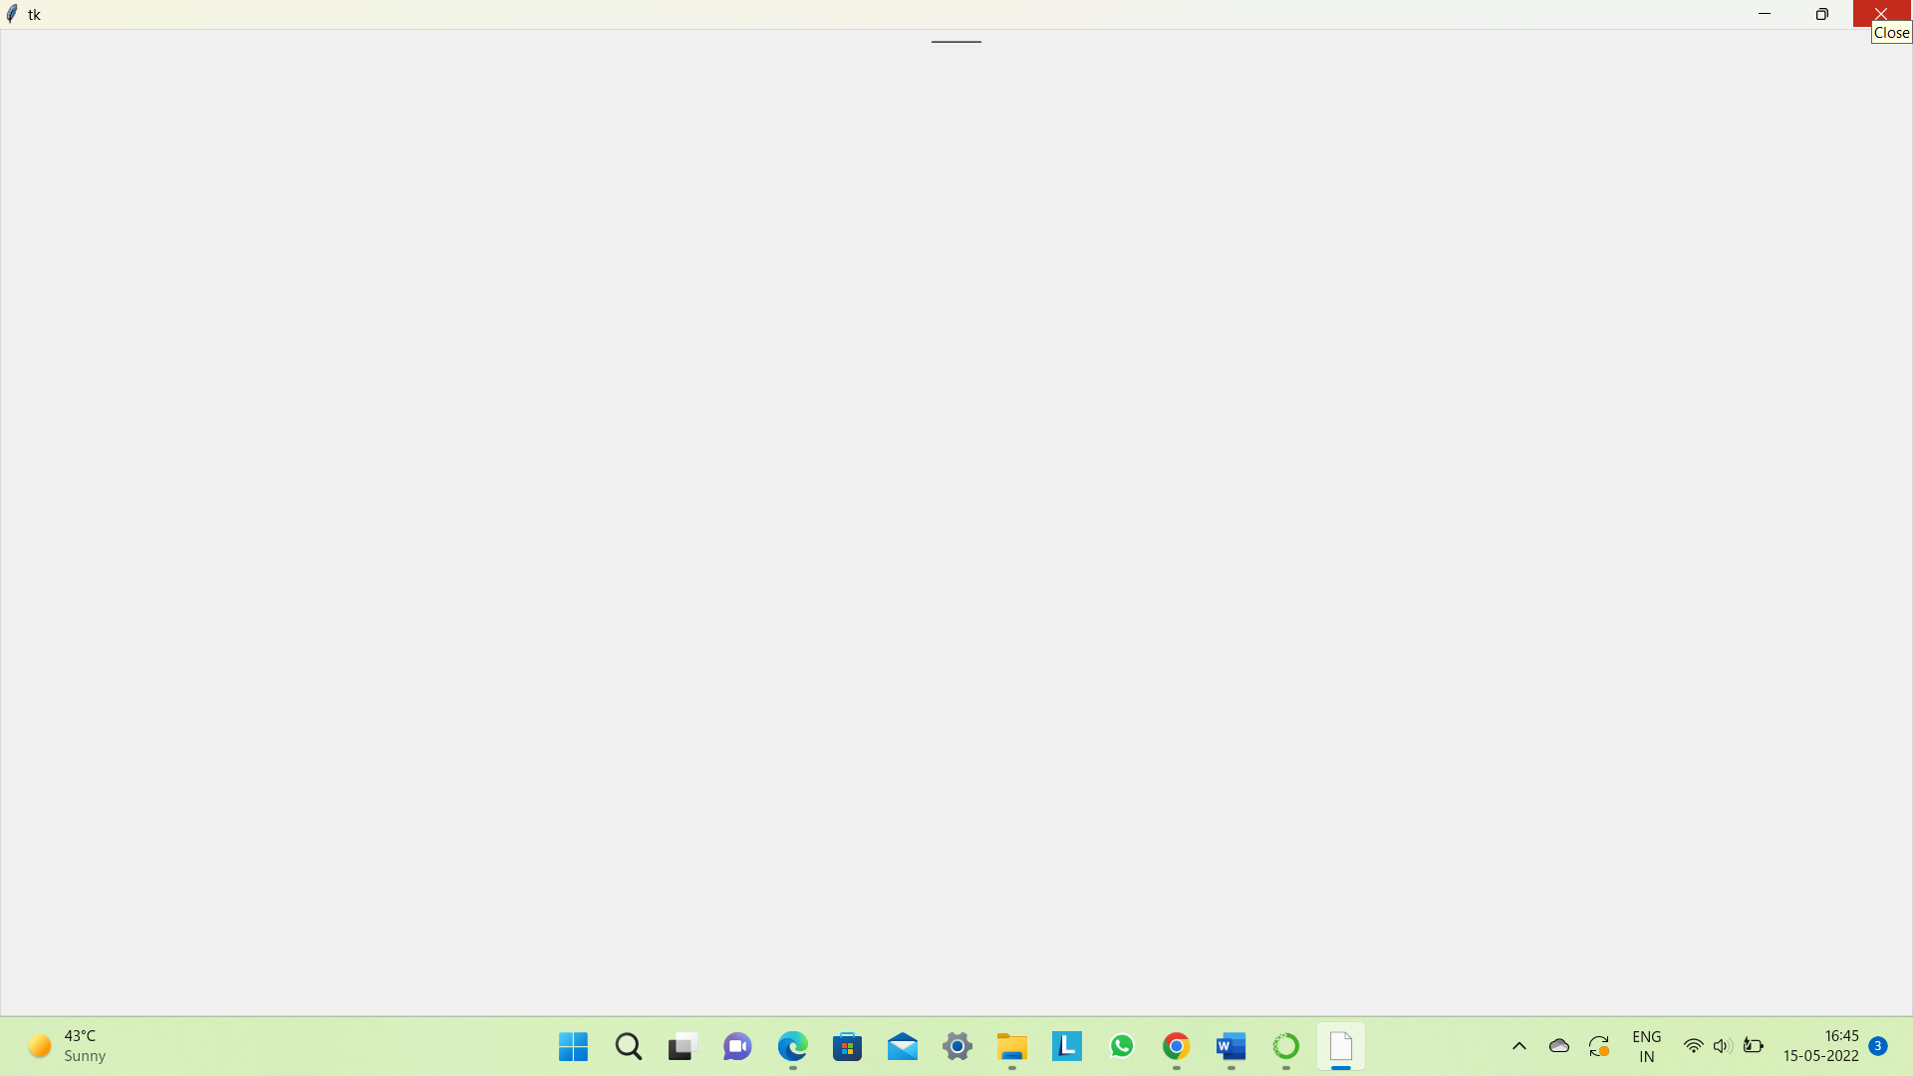

1. **CheckButton:**To select any number of options by displaying a number of options to a user as toggle buttons. The general syntax is:

w = CheckButton(master, option=value)

There are number of options which are used to change the format of this widget. Number of options can be passed as parameters separated by commas. Some of them are listed below.

* + **Title**: To set the title of the widget.
  + **activebackground**: to set the background color when widget is under the cursor.
  + **activeforeground**: to set the foreground color when widget is under the cursor.
  + **bg**: to set he normal background Steganography

Break

Secret Code: Attach a File:nd color.

* + **command**: to call a function.
  + **font**: to set the font on the button label.
  + **image**: to set the image on the widget.

|  |
| --- |
| **from** tkinter **import** **\***  master **=** Tk()  var1 **=** IntVar()  Checkbutton(master, text**=**'male', variable**=**var1).grid(row**=**0, sticky**=**W)  var2 **=** IntVar()  Checkbutton(master, text**=**'female', variable**=**var2).grid(row**=**1, sticky**=**W)  mainloop() |

Output:  
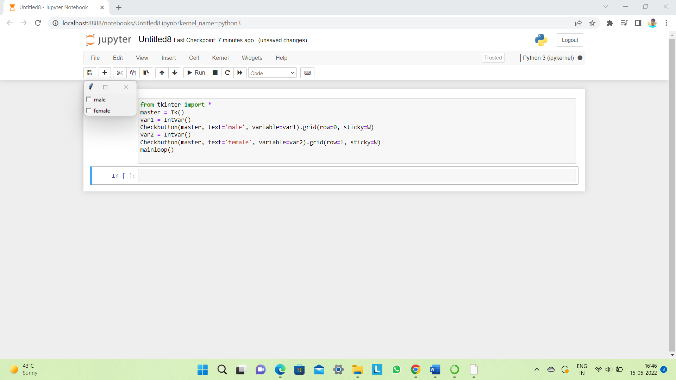

1. **Entry:**It is used to input the single line text entry from the user.. For multi-line text input, Text widget is used.  
   The general syntax is:

w=Entry(master, option=value)

master is the parameter used to represent the parent window.  
There are number of options which are used to change the format of the widget. Number of options can be passed as parameters separated by commas. Some of them are listed below.

* + **bd**: to set the border width in pixels.
  + **bg**: to set the normal background color.
  + **cursor**: to set the cursor used.
  + **command**: to call a function.
  + **highlightcolor**: to set the color shown in the focus highlight.
  + **width**: to set the width of the button.
  + **height**: to set the height of the button.

|  |
| --- |
| **from** tkinter **import** **\***  master **=** Tk()  Label(master, text**=**'First Name').grid(row**=**0)  Label(master, text**=**'Last Name').grid(row**=**1)  e1 **=** Entry(master)  e2 **=** Entry(master)  e1.grid(row**=**0, column**=**1)  e2.grid(row**=**1, column**=**1)  mainloop() |

Output:  
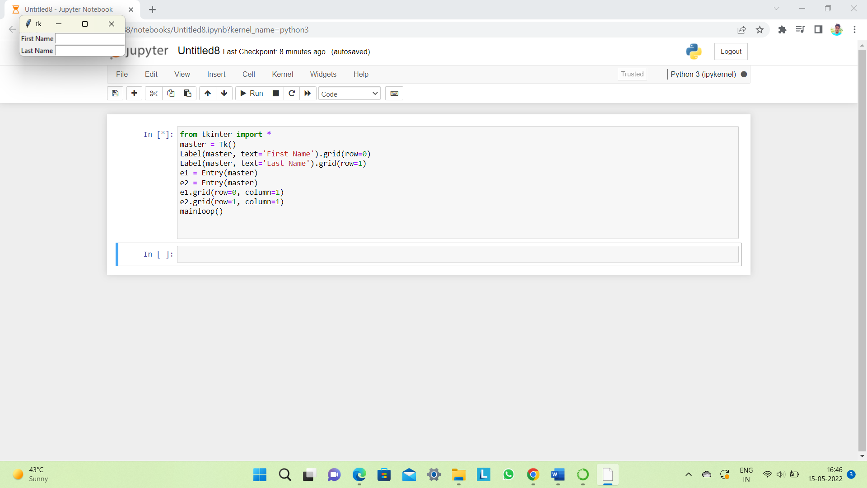

1. **Frame:** It acts as a container to hold the widgets. It is used for grouping and organizing the widgets. The general syntax is:

w = Frame(master, option=value)

master is the parameter used to represent the parent window.

There are number of options which are used to change the format of the widget. Number of options can be passed as parameters separated by commas. Some of them are listed below.

* + **highlightcolor**: To set the color of the focus highlight when widget has to be focused.
  + **bd**: to set the border width in pixels.
  + **bg**: to set the normal background color.
  + **cursor**: to set the cursor used.
  + **width**: to set the width of the widget.
  + **height**: to set the height of the widget.

|  |
| --- |
| **from** tkinter **import** **\***    root **=** Tk()  frame **=** Frame(root)  frame.pack()  bottomframe **=** Frame(root)  bottomframe.pack( side **=** BOTTOM )  redbutton **=** Button(frame, text **=** 'Red', fg **=**'red')  redbutton.pack( side **=** LEFT)  greenbutton **=** Button(frame, text **=** 'Brown', fg**=**'brown')  greenbutton.pack( side **=** LEFT )  bluebutton **=** Button(frame, text **=**'Blue', fg **=**'blue')  bluebutton.pack( side **=** LEFT )  blackbutton **=** Button(bottomframe, text **=**'Black', fg **=**'black')  blackbutton.pack( side **=** BOTTOM)  root.mainloop() |

Output:  
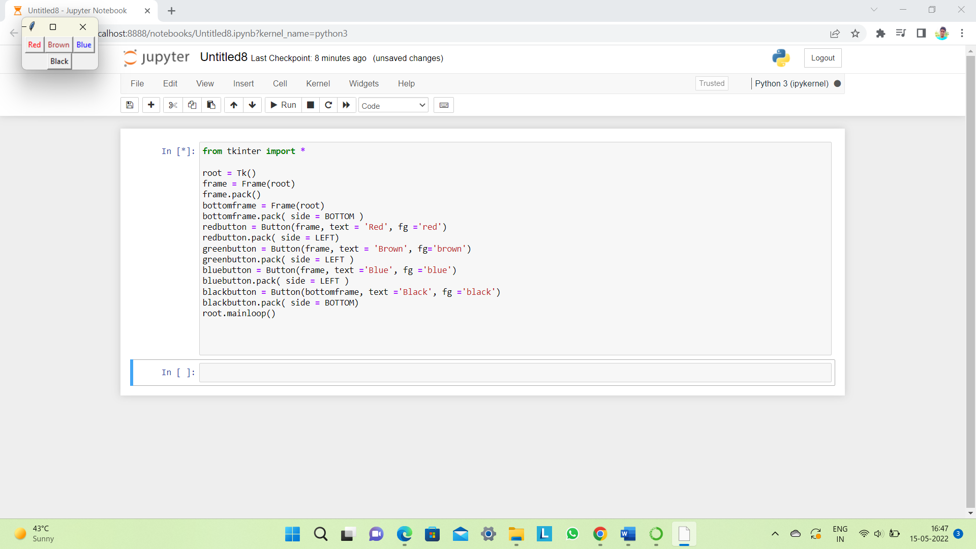

1. **Label**: It refers to the display box where you can put any text or image which can be updated any time as per the code.  
   The general syntax is:

w=Label(master, option=value)

master is the parameter used to represent the parent window.

There are number of options which are used to change the format of the widget. Number of options can be passed as parameters separated by commas. Some of them are listed below.

* + **bg**: to set he normal background color.
  + **bg** to set he normal background color.
  + **command**: to call a function.
  + **font**: to set the font on the button label.
  + **image**: to set the image on the button.
  + **width**: to set the width of the button.
  + **height**” to set the height of the button.

|  |
| --- |
| **from** tkinter **import** **\***  root **=** Tk()  w **=** Label(root, text**=**’E-attendance system')  w.pack()  root.mainloop() |

Output:

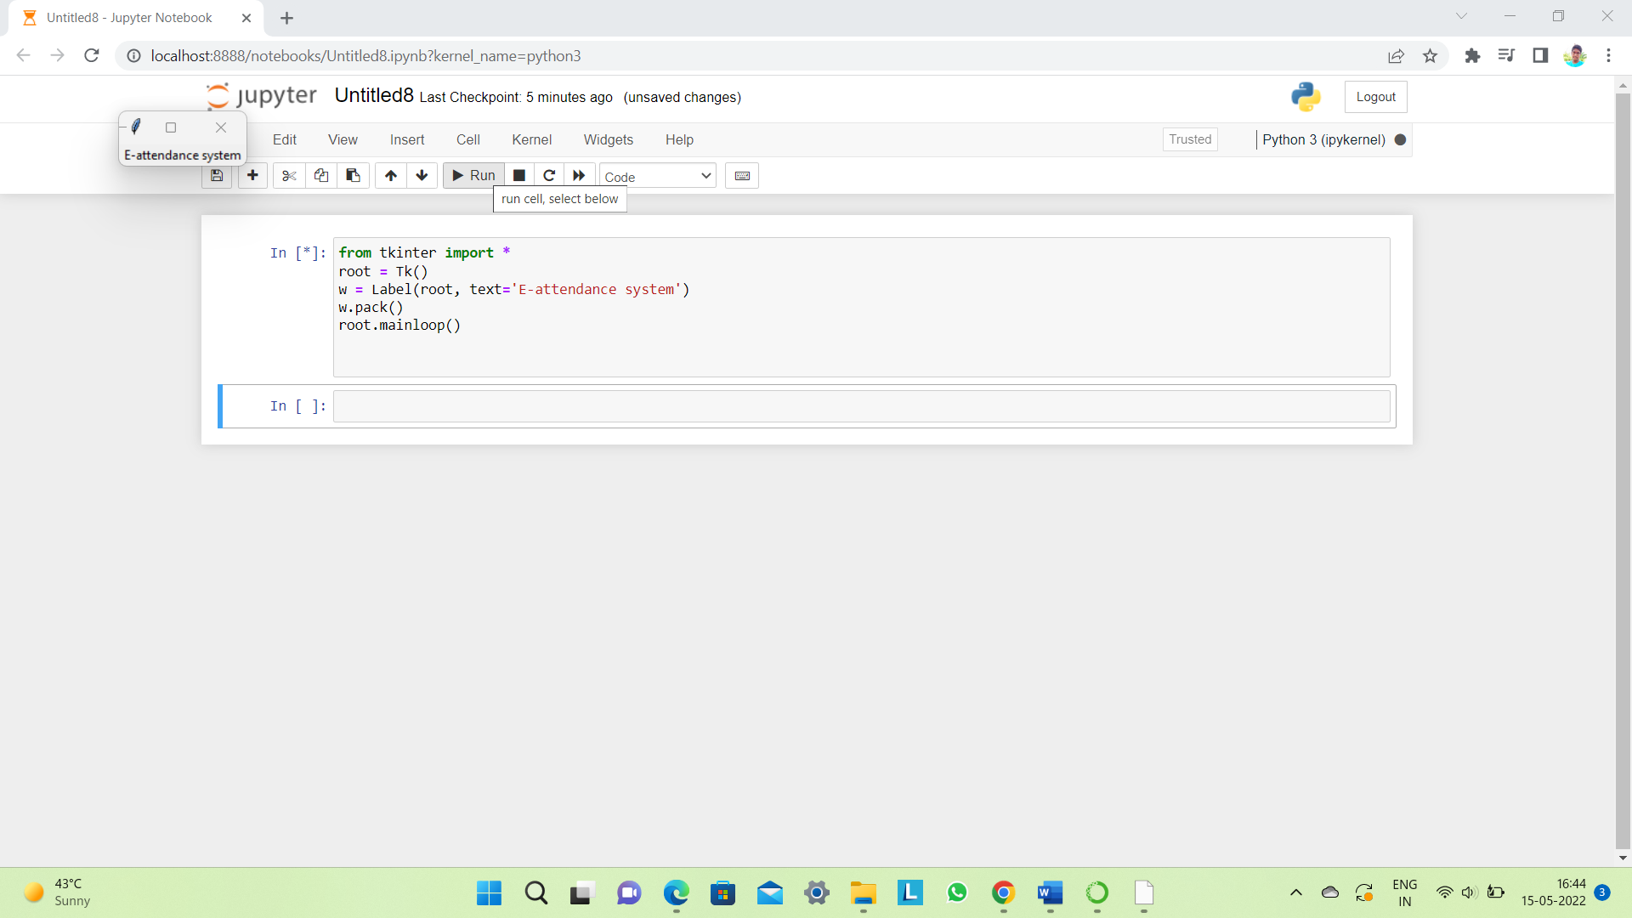

1. **Listbox**: It offers a list to the user from which the user can accept any number of options.  
   The general syntax is:

w = Listbox(master, option=value)

master is the parameter used to represent the parent window.

There are number of options which are used to change the format of the widget. Number of options can be passed as parameters separated by commas. Some of them are listed below.

* + **highlightcolor**: To set the color of the focus highlight when widget has to be focused.
  + **bg**: to set he normal background color.
  + **bd**: to set the border width in pixels.
  + **font**: to set the font on the button label.
  + **image**: to set the image on the widget.
  + **width**: to set the width of the widget.
  + **height**: to set the height of the widget.

|  |
| --- |
| from tkinter import *  top = Tk()  Lb = Listbox(top)  Lb.insert(1, 'Python')  Lb.insert(2, 'Java')  Lb.insert(3, 'C++')  Lb.insert(4, 'Any other')  Lb.pack()  top.mainloop() |

Output:  
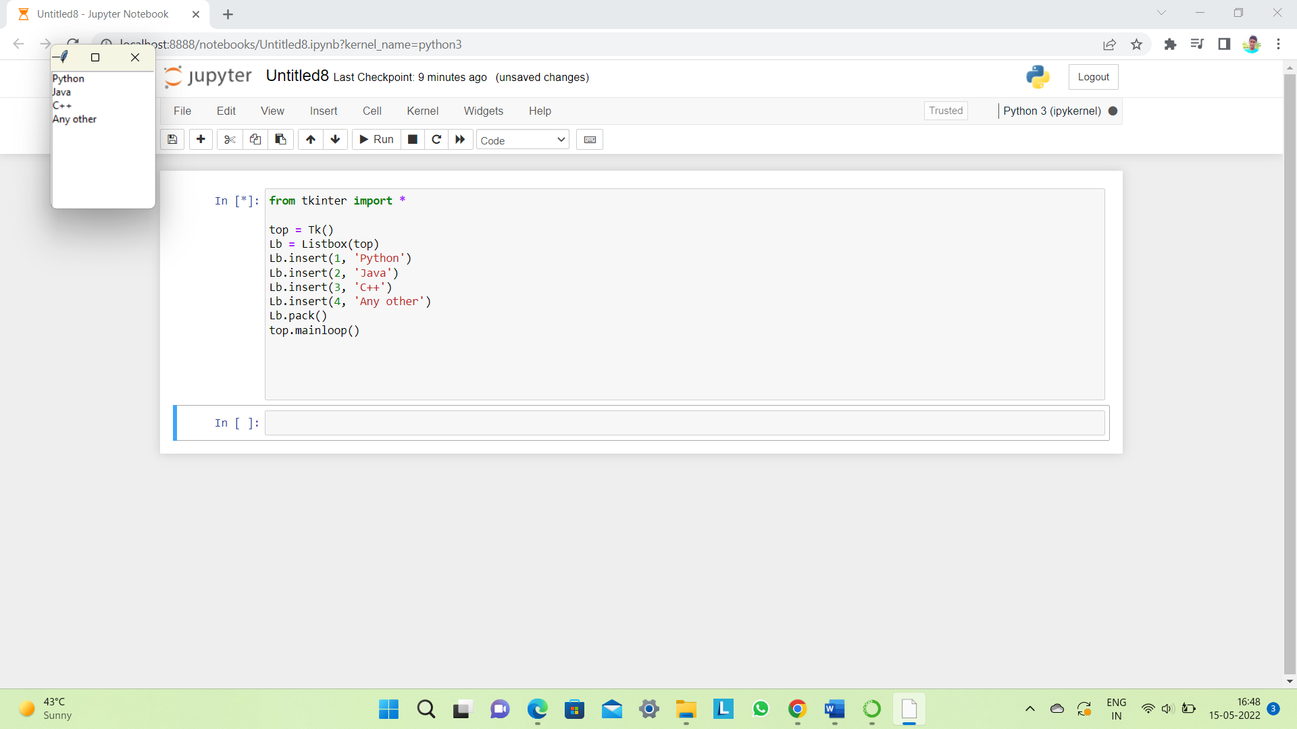

1. **MenuButton**: It is a part of top-down menu which stays on the window all the time. Every menubutton has its own functionality. The general syntax is:

w = MenuButton(master, option=value)

master is the parameter used to represent the parent window.

There are number of options which are used to change the format of the widget. Number of options can be passed as parameters separated by commas. Some of them are listed below.

* + **activebackground**: To set the background when mouse is over the widget.
  + **activeforeground**: To set the foreground when mouse is over the widget.
  + **bg**: to set he normal background color.
  + **bd**: to set the size of border around the indicator.
  + **cursor**: To appear the cursor when the mouse over the menubutton.
  + **image**: to set the image on the widget.
  + **width**: to set the width of the widget.
  + **height**: to set the height of the widget.
  + **highlightcolor**: To set the color of the focus highlight when widget has to be focused.

|  |
| --- |
| **from** tkinter **import** **\***    top **=** Tk()  mb **=**  Menubutton ( top, text **=** &quot;GfG&quot;)  mb.grid()  mb.menu  **=**  Menu ( mb, tearoff **=** 0 )  mb[&quot;menu&quot;]  **=**  mb.menu  cVar  **=** IntVar()  aVar **=** IntVar()  mb.menu.add_checkbutton ( label **=**'Contact', variable **=** cVar )  mb.menu.add_checkbutton ( label **=** 'About', variable **=** aVar )  mb.pack()  top.mainloop() |

Output:  
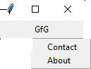

1. **Menu**: It is used to create all kinds of menus used by the application.  
   The general syntax is:

w = Menu(master, option=value)

master is the parameter used to represent the parent window.

There are number of options which are used to change the format of this widget. Number of options can be passed as parameters separated by commas. Some of them are listed below.

* + **title**: To set the title of the widget.
  + **activebackground**: to set the background color when widget is under the cursor.
  + **activeforeground**: to set the foreground color when widget is under the cursor.
  + **bg**: to set he normal background color.
  + **command**: to call a function.
  + **font**: to set the font on the button label.
  + **image**: to set the image on the widget.

|  |
| --- |
| **from** tkinter **import** **\***    root **=** Tk()  menu **=** Menu(root)  root.config(menu**=**menu)  filemenu **=** Menu(menu)  menu.add_cascade(label**=**'File', menu**=**filemenu)  filemenu.add_command(label**=**'New')  filemenu.add_command(label**=**'Open...')  filemenu.add_separator()  filemenu.add_command(label**=**'Exit', command**=**root.quit)  helpmenu **=** Menu(menu)  menu.add_cascade(label**=**'Help', menu**=**helpmenu)  helpmenu.add_command(label**=**'About')  mainloop() |

Output:  
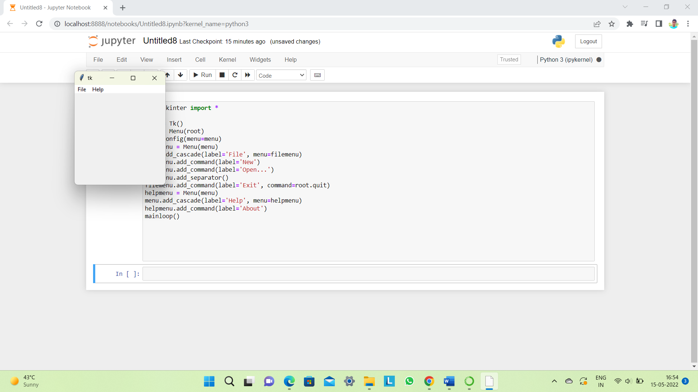

1. **Message**: It refers to the multi-line and non-editable text. It works same as that of Label.  
   The general syntax is:

w = Message(master, option=value)

master is the parameter used to represent the parent window.

There are number of options which are used to change the format of the widget. Number of options can be passed as parameters separated by commas. Some of them are listed below.

* + **bd**: to set the border around the indicator.
  + **bg**: to set he normal background color.
  + **font**: to set the font on the button label.
  + **image**: to set the image on the widget.
  + **width**: to set the width of the widget.
  + **height**: to set the height of the widget.

|  |
| --- |
| **from** tkinter **import** **\***  main **=** Tk()  ourMessage **=**'This is our Message'  messageVar **=** Message(main, text **=** ourMessage)  messageVar.config(bg**=**'lightgreen')  messageVar.pack( )  main.mainloop( ) |

Output:  
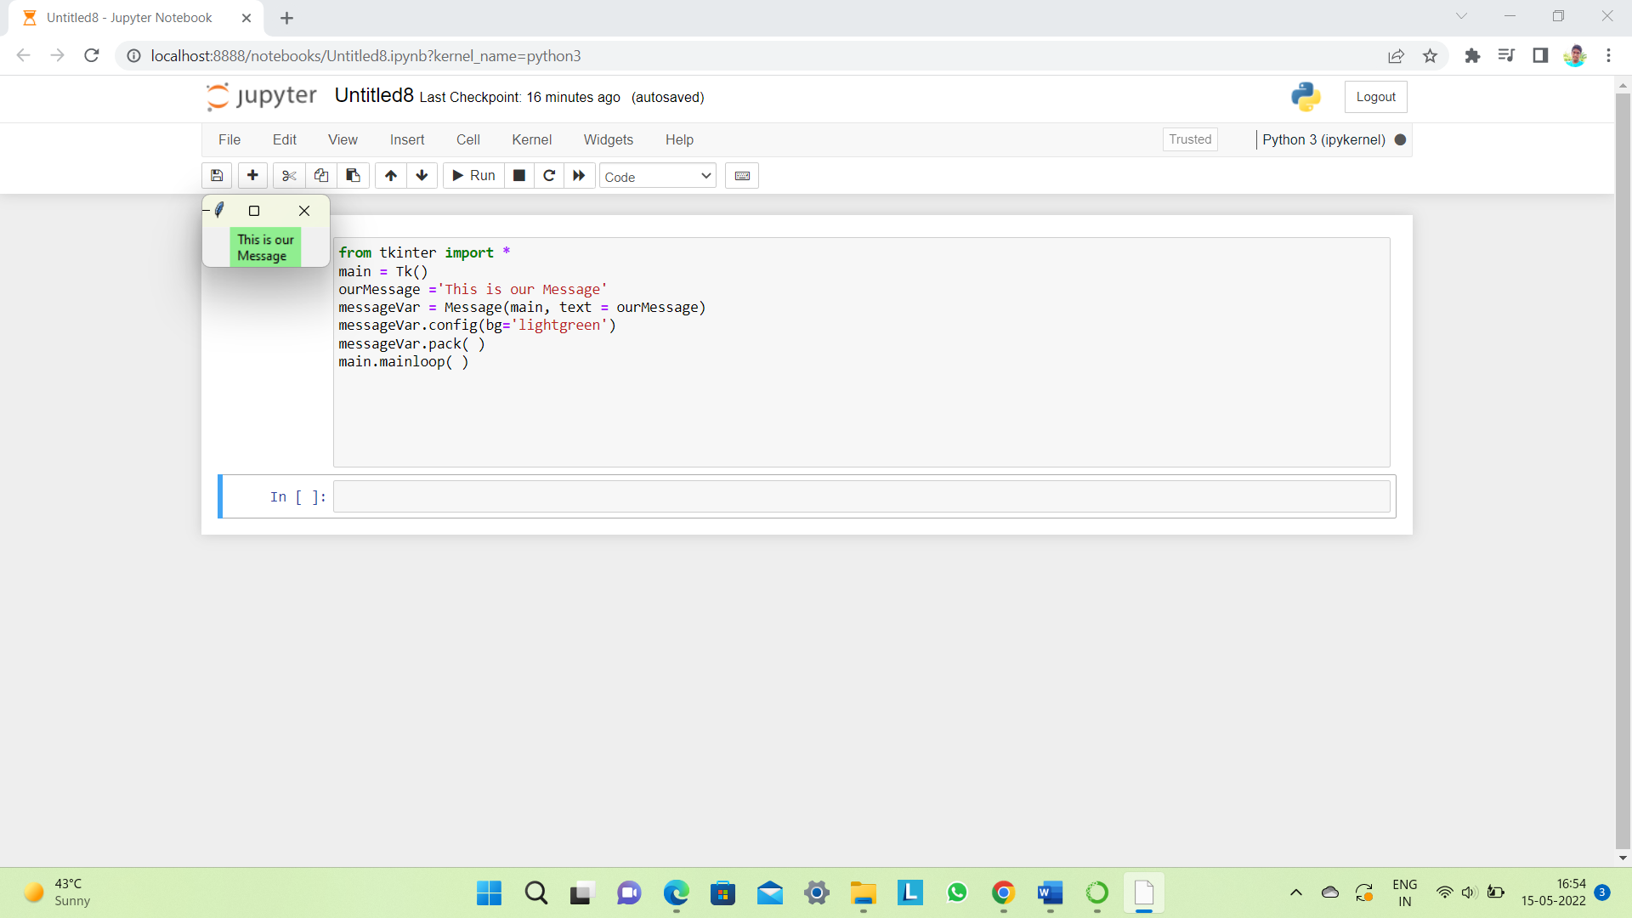

1. **RadioButton:**It is used to offer multi-choice option to the user. It offers several options to the user and the user has to choose one option.  
   The general syntax is:

w = RadioButton(master, option=value)

There are number of options which are used to change the format of this widget. Number of options can be passed as parameters separated by commas. Some of them are listed below.

* + **activebackground**: to set the background color when widget is under the cursor.
  + **activeforeground**: to set the foreground color when widget is under the cursor.
  + **bg**: to set he normal background color.
  + **command**: to call a function.
  + **font**: to set the font on the button label.
  + **image**: to set the image on the widget.
  + **width**: to set the width of the label in characters.
  + **height**: to set the height of the label in characters.

|  |
| --- |
| **from** tkinter **import** **\***  root **=** Tk()  v **=** IntVar()  Radiobutton(root, text**=**'GfG', variable**=**v, value**=**1).pack(anchor**=**W)  Radiobutton(root, text**=**'MIT', variable**=**v, value**=**2).pack(anchor**=**W)  mainloop() |

Output:  
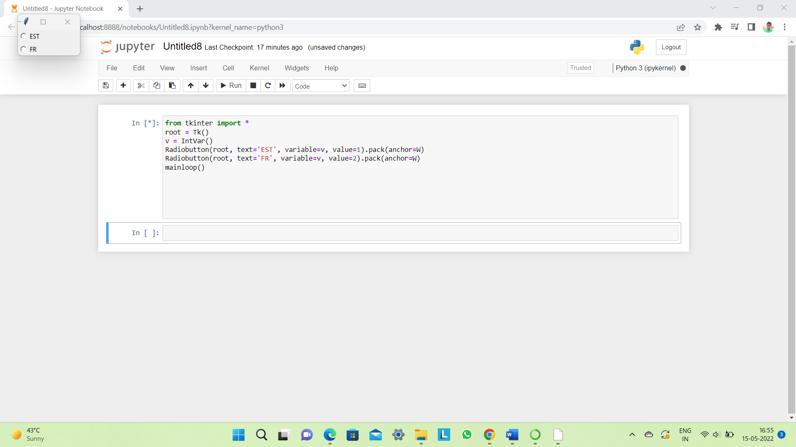

1. **Scale:**It is used to provide a graphical slider that allows to select any value from that scale. The general syntax is:

w = Scale(master, option=value)

master is the parameter used to represent the parent window.

There are number of options which are used to change the format of the widget. Number of options can be passed as parameters separated by commas. Some of them are listed below.

* + **cursor**: To change the cursor pattern when the mouse is over the widget.
  + **activebackground**: To set the background of the widget when mouse is over the widget.
  + **bg**: to set he normal background color.
  + **orient**: Set it to HORIZONTAL or VERTICAL according to the requirement.
  + **from_**: To set the value of one end of the scale range.
  + **to**: To set the value of the other end of the scale range.
  + **image**: to set the image on the widget.
  + **width**: to set the width of the widget.

|  |
| --- |
| **from** tkinter **import** **\***  master **=** Tk()  w **=** Scale(master, from_**=**0, to**=**42)  w.pack()  w **=** Scale(master, from_**=**0, to**=**200, orient**=**HORIZONTAL)  w.pack()  mainloop() |

Output:  
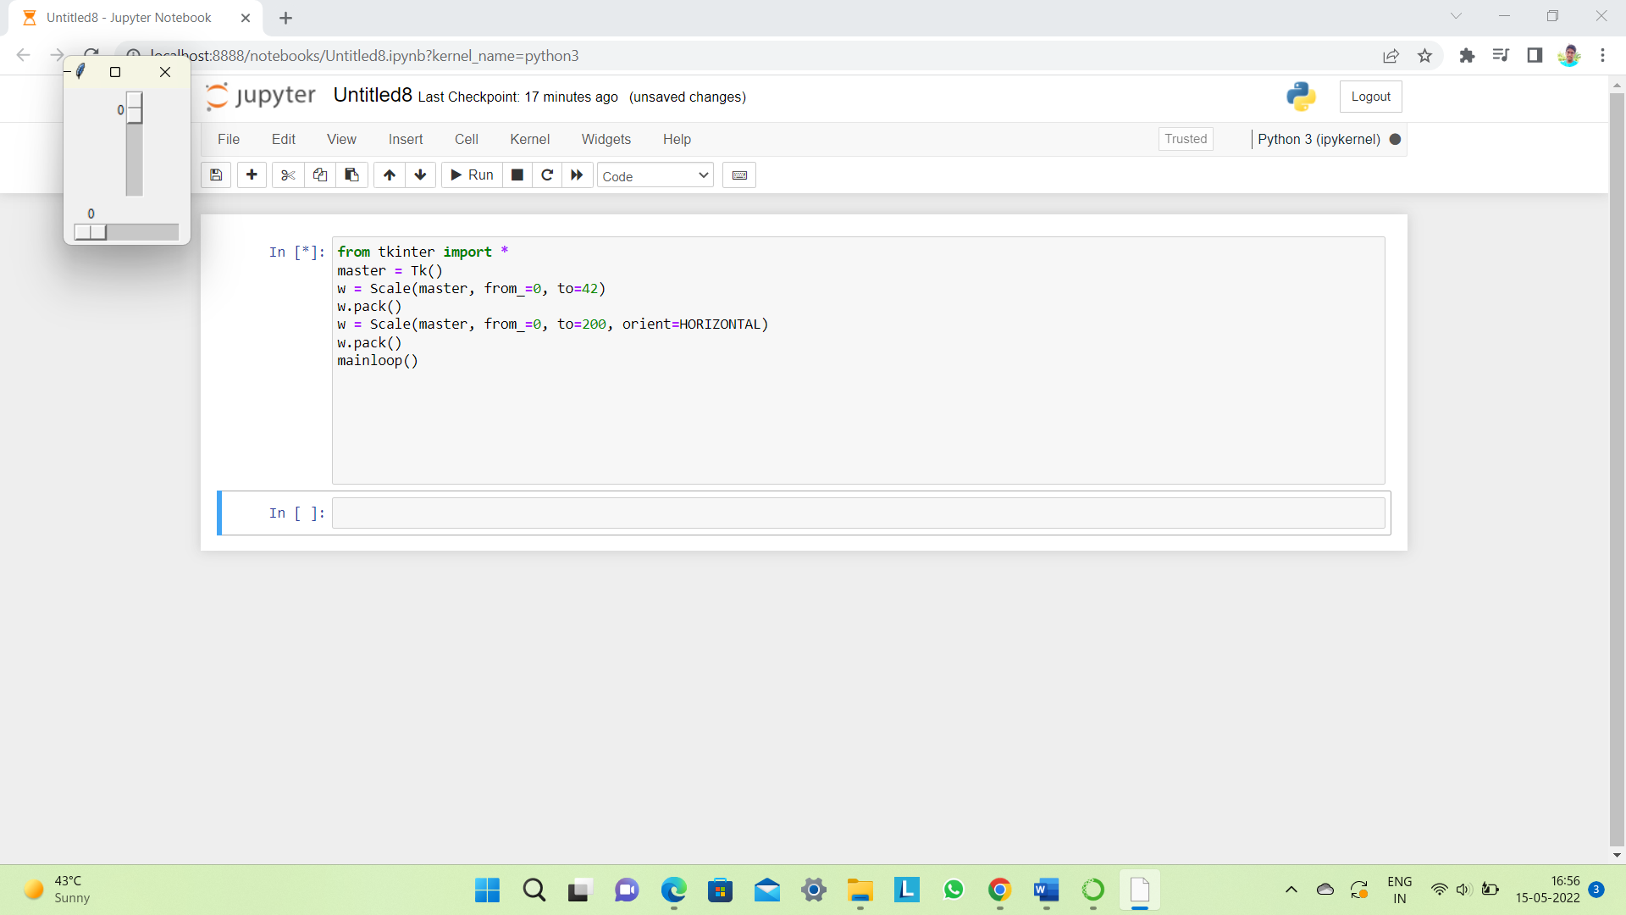

1. **Scrollbar**: It refers to the slide controller which will be used to implement listed widgets.  
   The general syntax is:

w = Scrollbar(master, option=value)

master is the parameter used to represent the parent window.

There are number of options which are used to change the format of the widget. Number of options can be passed as parameters separated by commas. Some of them are listed below.

* + **width**: to set the width of the widget.
  + **activebackground**: To set the background when mouse is over the widget.
  + **bg**: to set he normal background color.
  + **bd**: to set the size of border around the indicator.
  + **cursor**: To appear the cursor when the mouse over the menubutton.

|  |
| --- |
| **from** tkinter **import** **\***  root **=** Tk()  scrollbar **=** Scrollbar(root)  scrollbar.pack( side **=** RIGHT, fill **=** Y )  mylist **=** Listbox(root, yscrollcommand **=** scrollbar.set )  **for** line **in** range(100):     mylist.insert(END, 'This is line number' **+** str(line))  mylist.pack( side **=** LEFT, fill **=** BOTH )  scrollbar.config( command **=** mylist.yview )  mainloop() |

Output:  
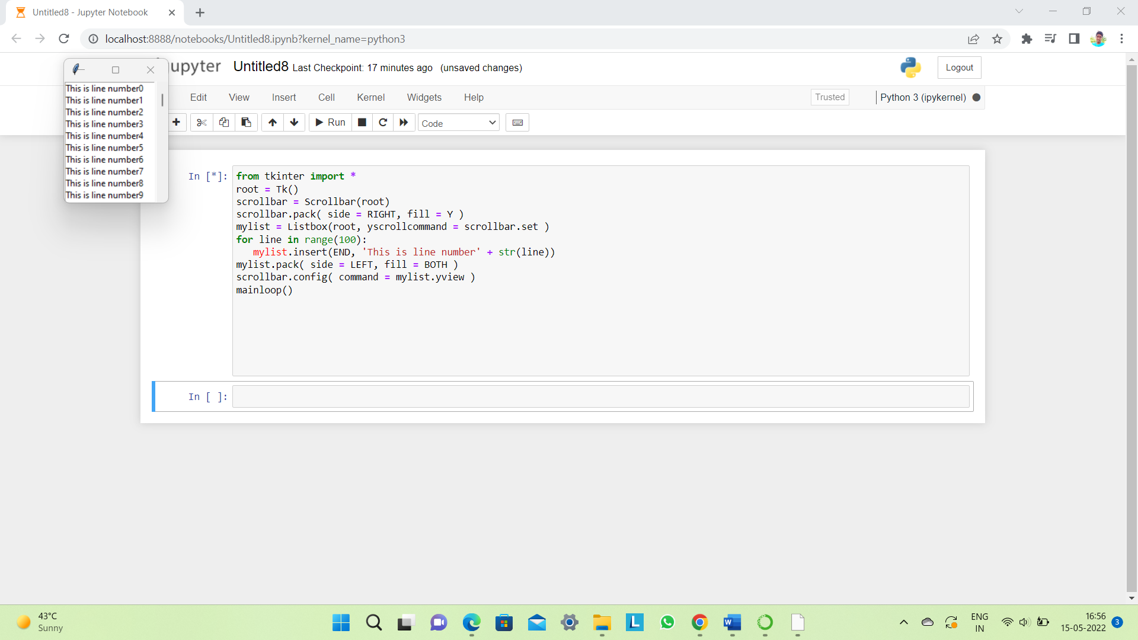

1. **Text:**To edit a multi-line text and format the way it has to be displayed.  
   The general syntax is:

w =Text(master, option=value)

There are number of options which are used to change the format of the text. Number of options can be passed as parameters separated by commas. Some of them are listed below.

* + **highlightcolor**: To set the color of the focus highlight when widget has to be focused.
  + **insertbackground**: To set the background of the widget.
  + **bg**: to set he normal background color.
  + **font**: to set the font on the button label.
  + **image**: to set the image on the widget.
  + **width**: to set the width of the widget.
  + **height**: to set the height of the widget.

|  |
| --- |
| **from** tkinter **import** **\***  root **=** Tk()  T **=** Text(root, height**=**2, width**=**30)  T.pack()  T.insert(END, 'GeeksforGeeks\nBEST WEBSITE\n')  mainloop() |

Output:  
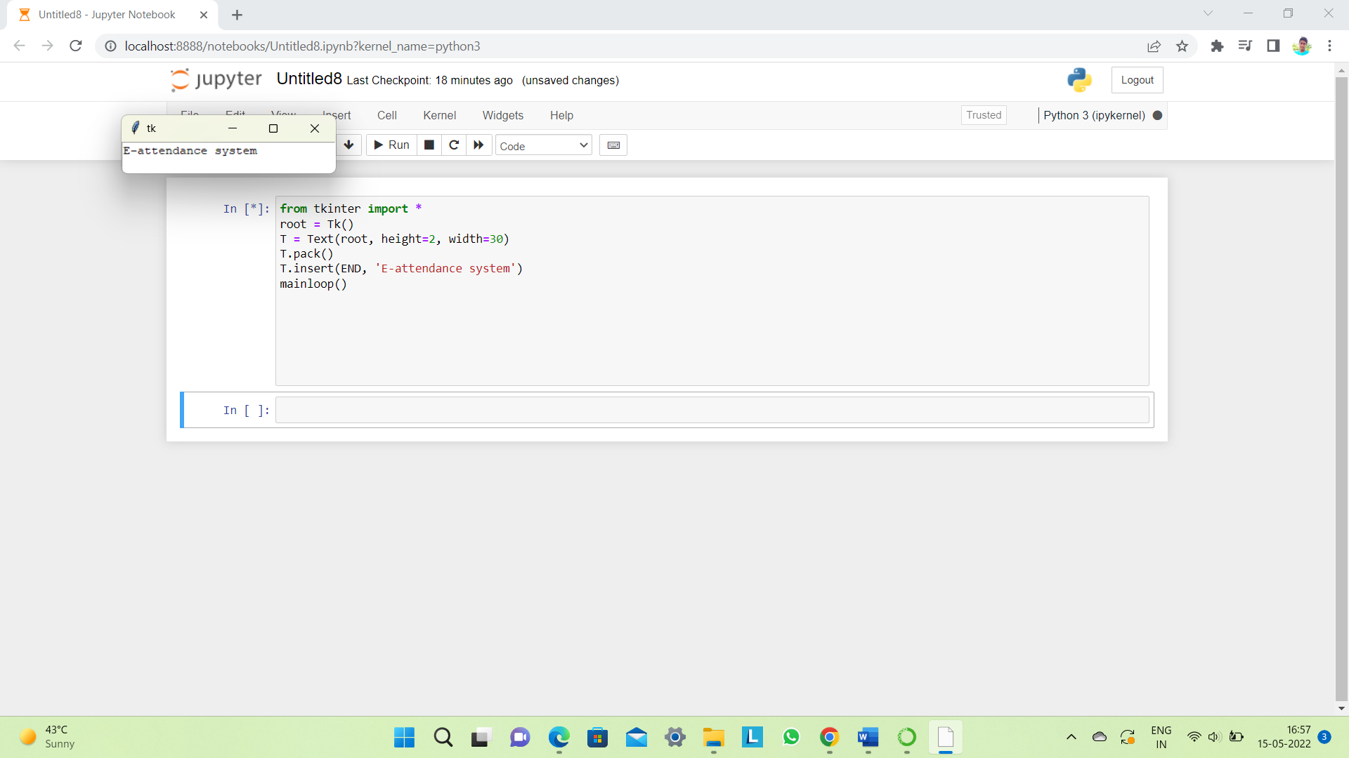

1. **TopLevel:**This widget is directly controlled by the window manager. It don’t need any parent window to work on.The general syntax is:

w = TopLevel(master, option=value)

There are number of options which are used to change the format of the widget. Number of options can be passed as parameters separated by commas. Some of them are listed below.

* + **bg**: to set he normal background color.
  + **bd**: to set the size of border around the indicator.
  + **cursor**: To appear the cursor when the mouse over the menubutton.
  + **width**: to set the width of the widget.
  + **height**: to set the height of the widget.

|  |
| --- |
| **from** tkinter **import** **\***  root **=** Tk()  root.title('GfG')  top **=** Toplevel()  top.title('Python')  top.mainloop() |

Output:  
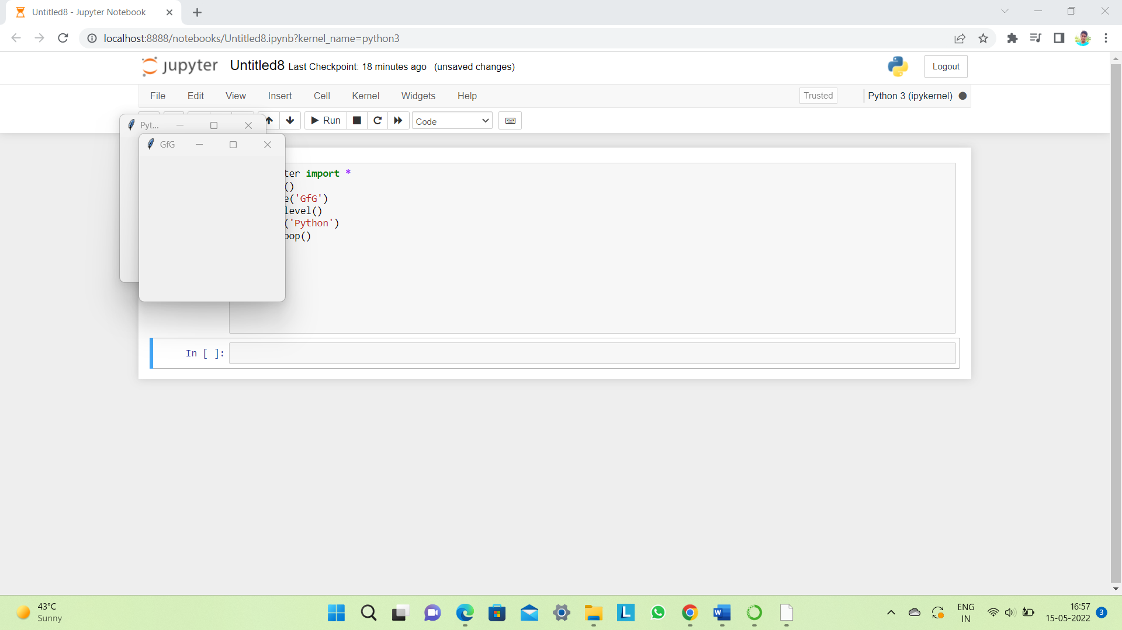

1. **SpinBox:**It is an entry of ‘Entry’ widget. Here, value can be input by selecting a fixed value of numbers. The general syntax is:

w = SpinBox(master, option=value)

There are number of options which are used to change the format of the widget. Number of options can be passed as parameters separated by commas. Some of them are listed below.

* + **bg**: to set he normal background color.
  + **bd**: to set the size of border around the indicator.
  + **cursor**: To appear the cursor when the mouse over the menubutton.
  + **command**: To call a function.
  + **width**: to set the width of the widget.
  + **activebackground**: To set the background when mouse is over the widget.
  + **disabledbackground**: To disable the background when mouse is over the widget.
  + **from_**: To set the value of one end of the range.
  + **to**: To set the value of the other end of the range.

|  |
| --- |
| **from** tkinter **import** **\***  master **=** Tk()  w **=** Spinbox(master, from_ **=** 0, to **=** 10)  w.pack()  mainloop() |

Output:  
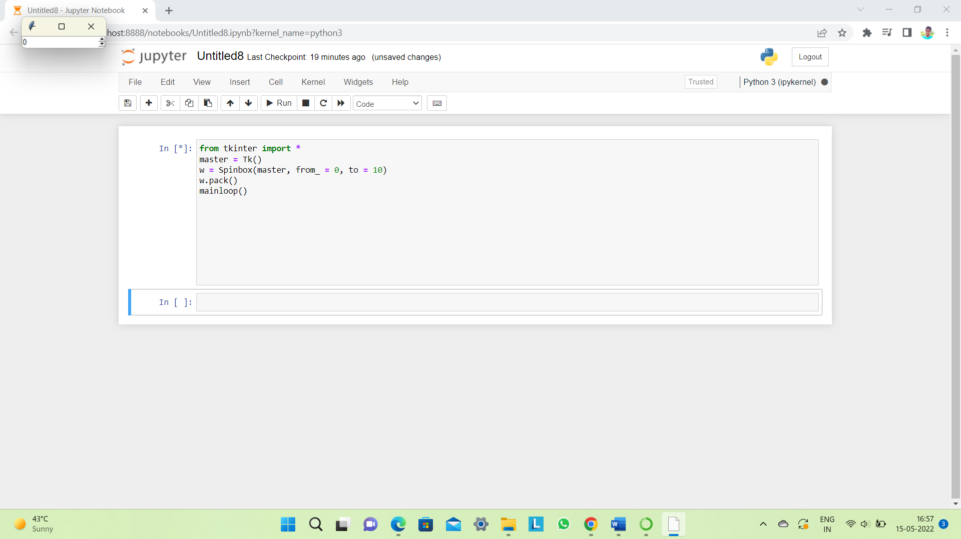

1. **PannedWindow**It is a container widget which is used to handle number of panes arranged in it. The general syntax is:

w = PannedWindow(master, option=value)

master is the parameter used to represent the parent window.  
There are number of options which are used to change the format of the widget. Number of options can be passed as parameters separated by commas. Some of them are listed below.

* + **bg**: to set he normal background color.
  + **bd**: to set the size of border around the indicator.
  + **cursor**: To appear the cursor when the mouse over the menubutton.
  + **width**: to set the width of the widget.
  + **height**: to set the height of the widget.

|  |
| --- |
| **from** tkinter **import** **\***  m1 **=** PanedWindow()  m1.pack(fill **=** BOTH, expand **=** 1)  left **=** Entry(m1, bd **=** 5)  m1.add(left)  m2 **=** PanedWindow(m1, orient **=** VERTICAL)  m1.add(m2)  top **=** Scale( m2, orient **=** HORIZONTAL)  m2.add(top)  mainloop() |

Output:  
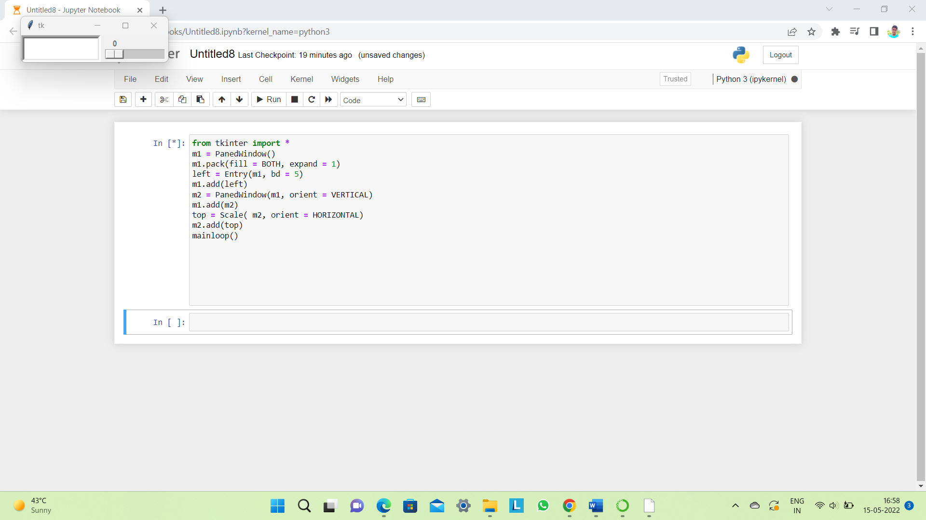

1. **OUTPUT**
   1. The front end of the project (GUI)

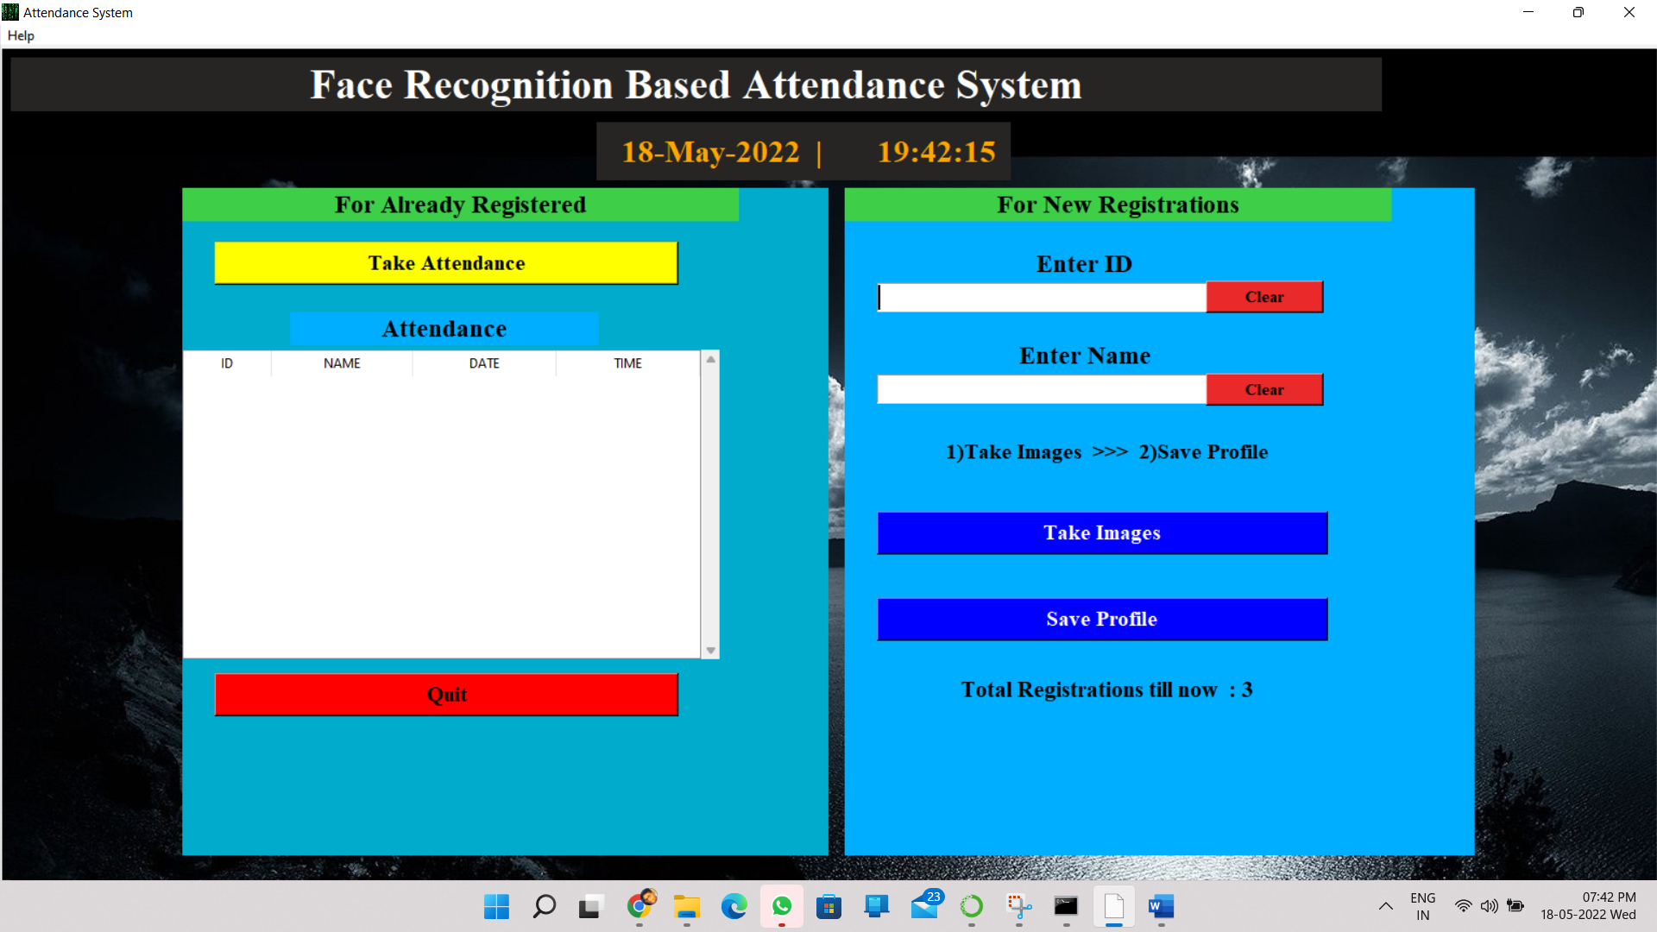

* 1. Help menu

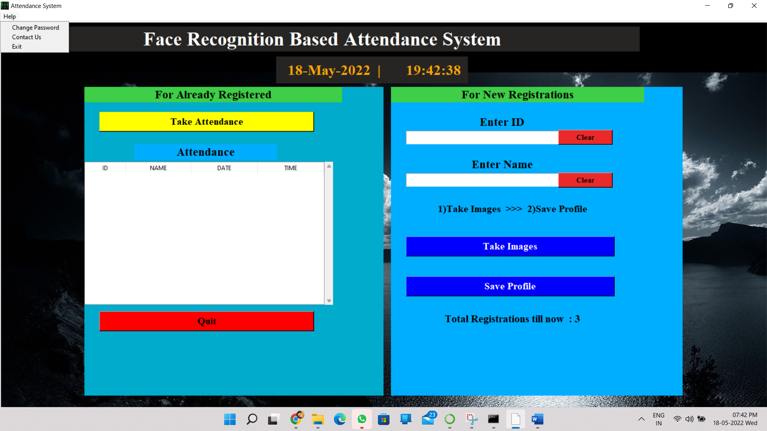

* 1. To change password

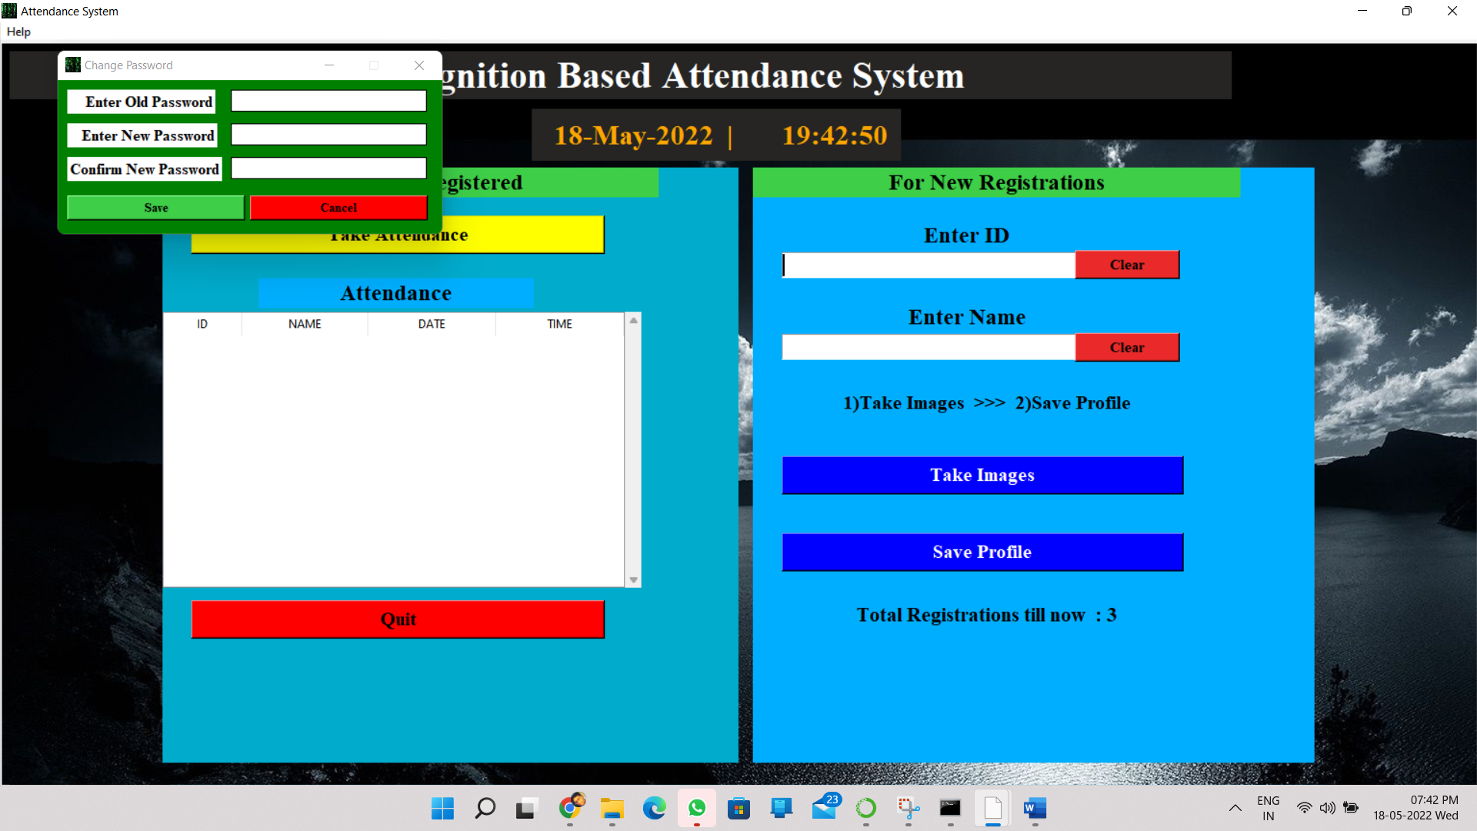

* 1. For contact help

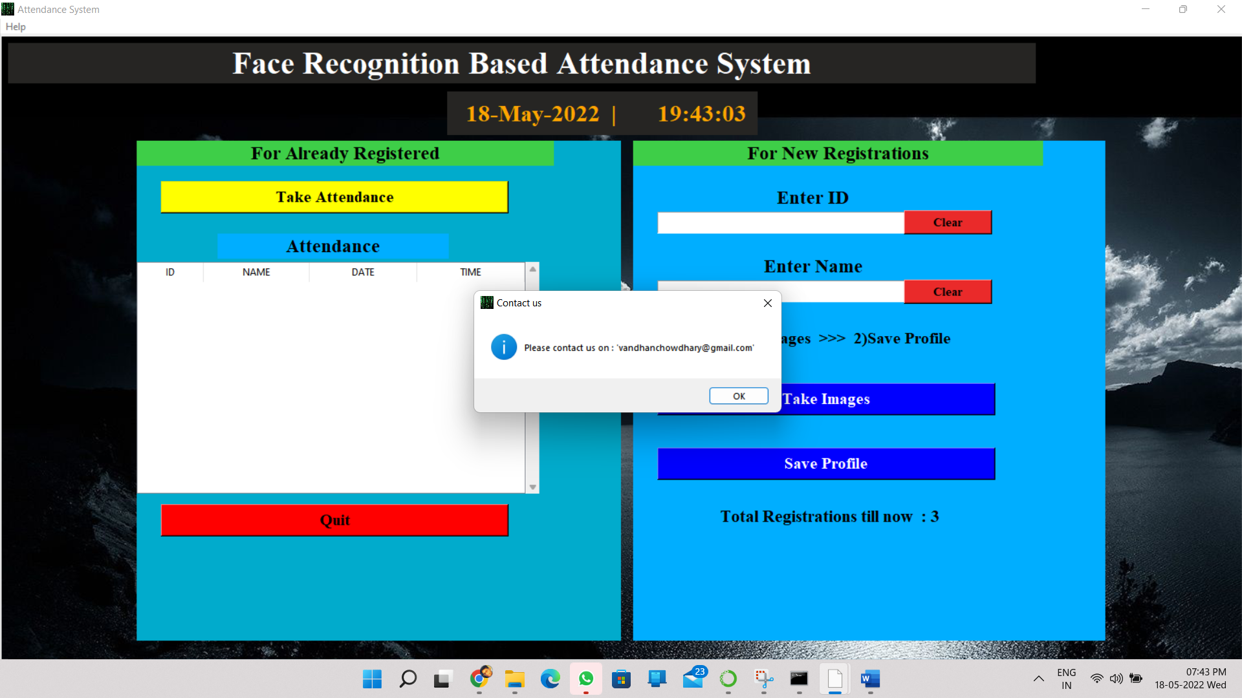

* 1. Taking the images of new registration by accessing the camera.

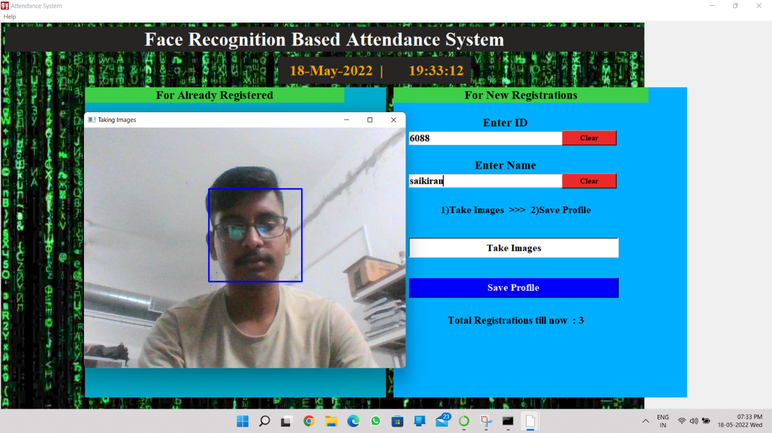

* 1. Images are taken for new registration

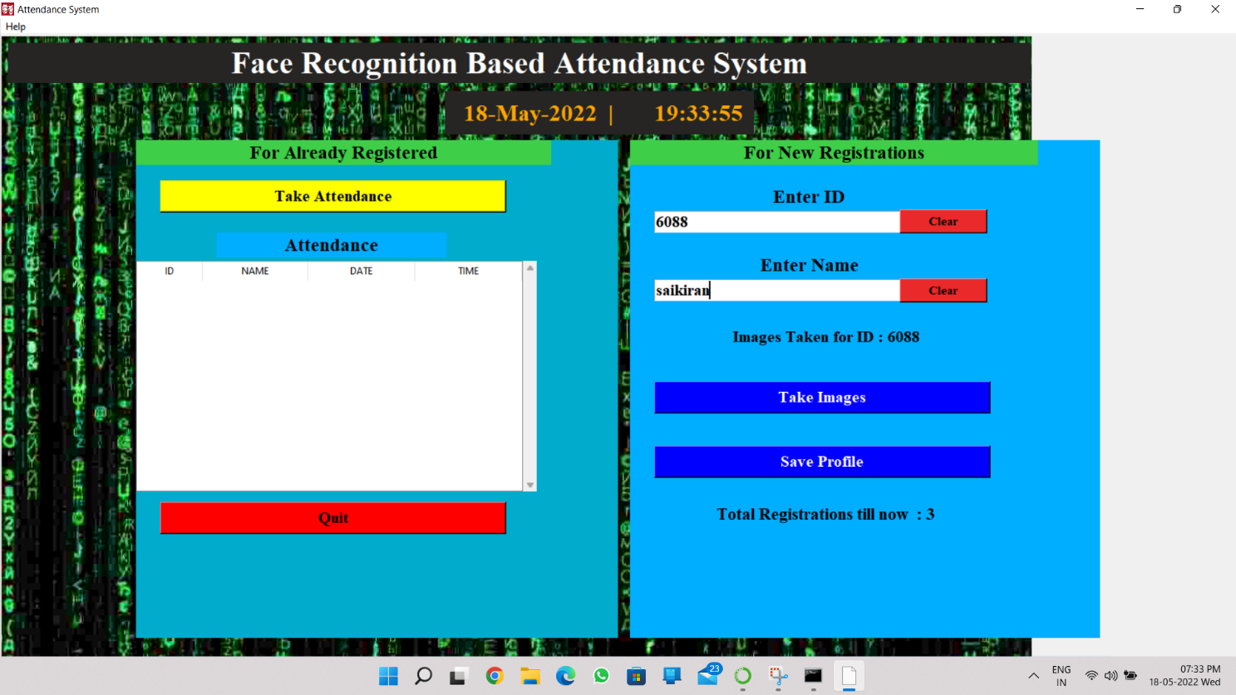

* 1. Querying password to save the new registration

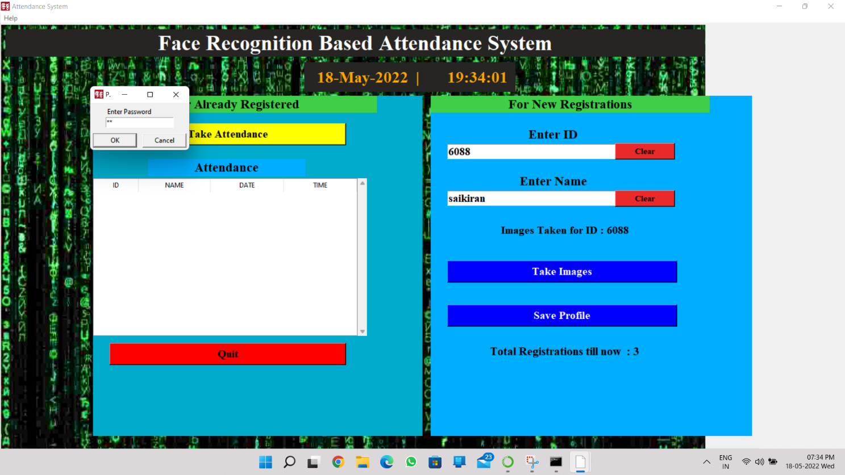

* 1. Showing successful registration

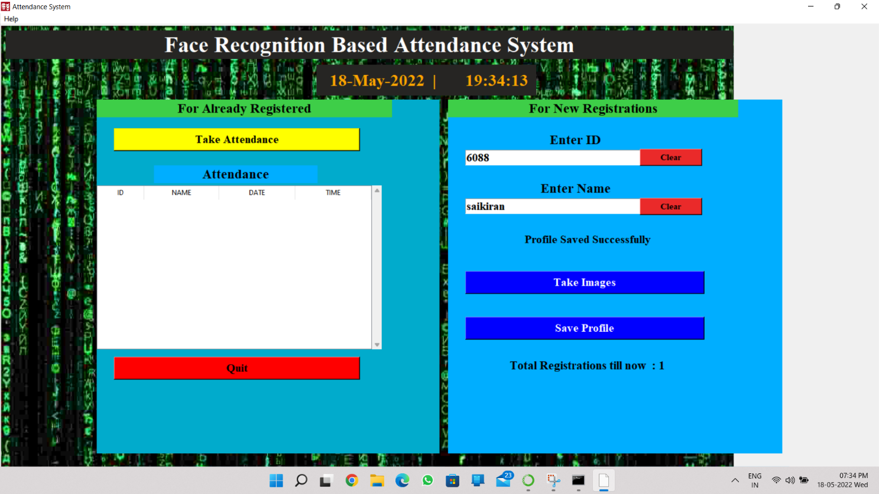

* 1. Taking attendance

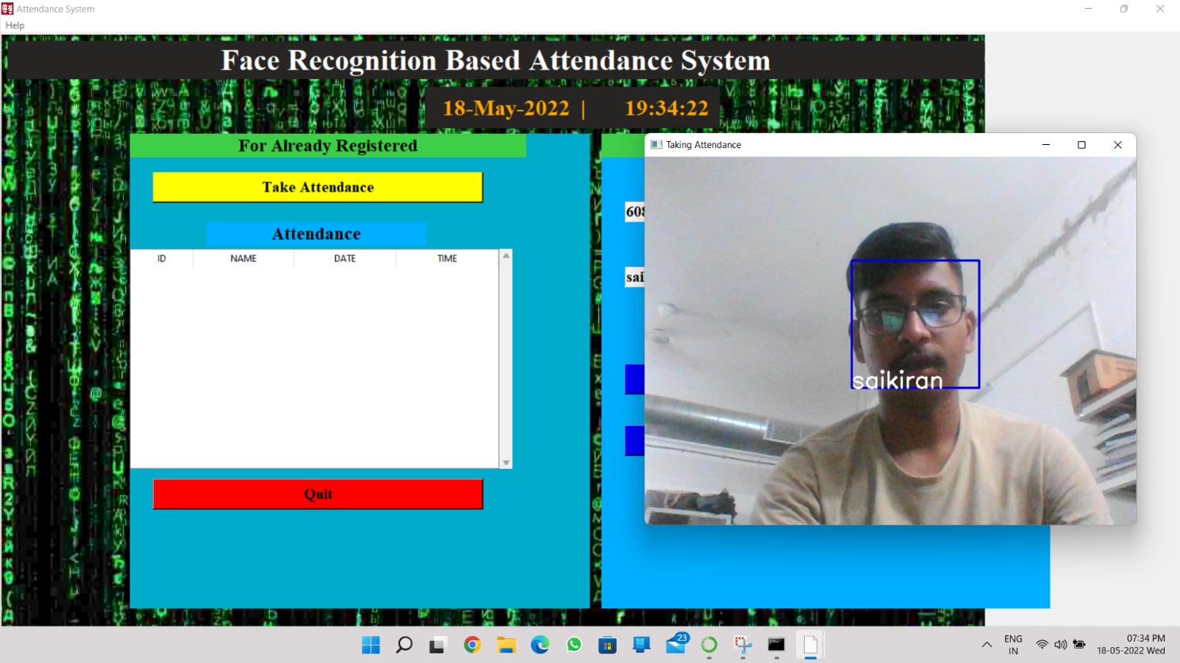

* 1. Showing the record for the Attendance

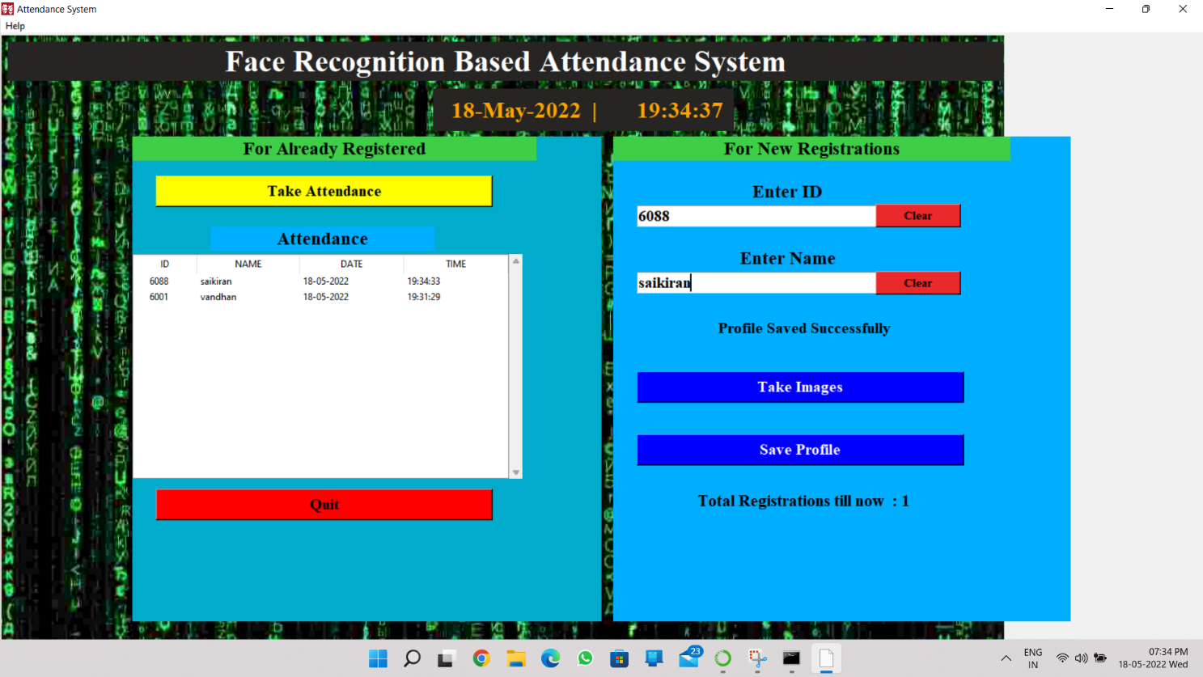

* 1. The attendance, marked will be saved in these csv files

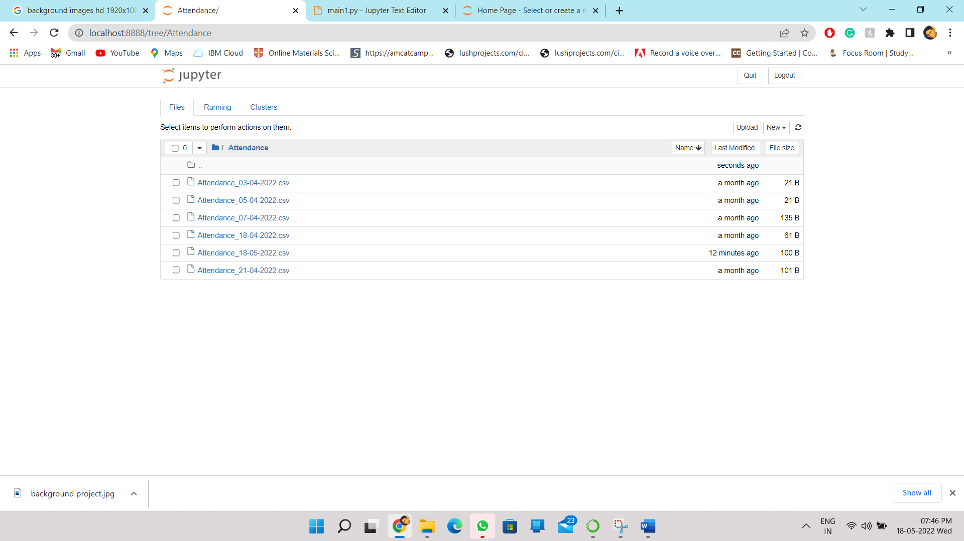

* 1. Showing the attendance marked on the particular day

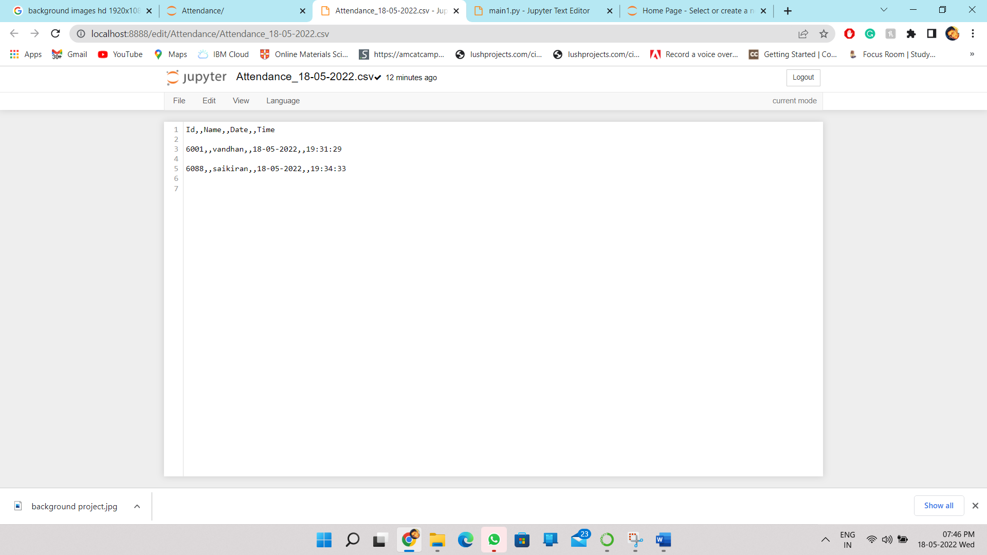

* 1. The data of the students details

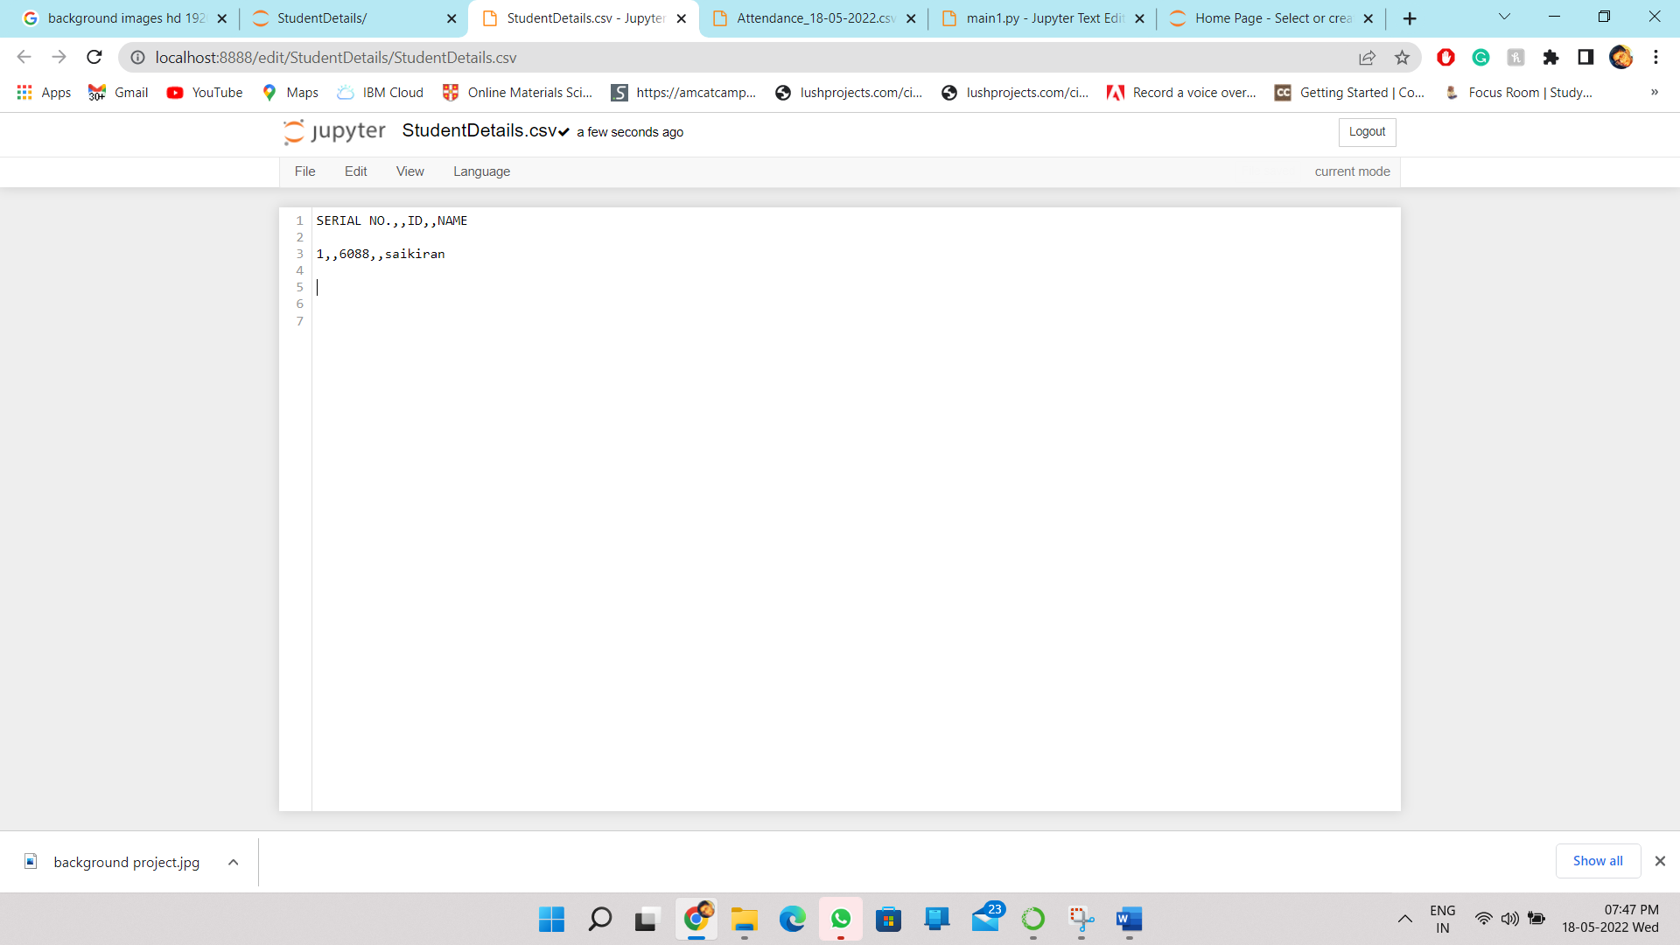

* 1. The training images of the students

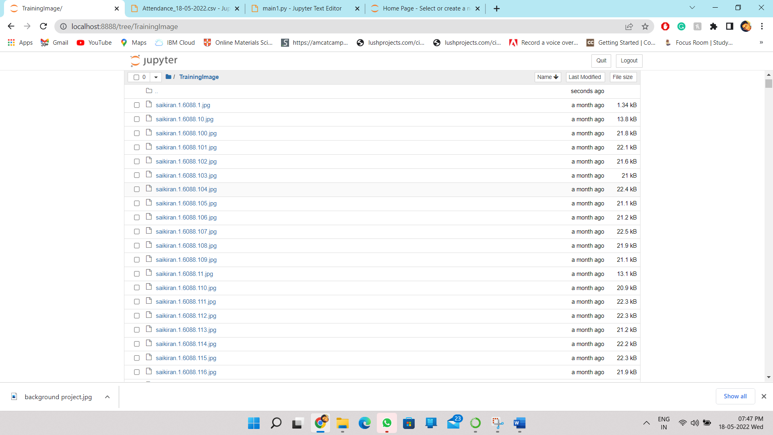

1. REFERENCES
   1. <https://www.analyticsvidhya.com/blog/2021/07/understanding-face-recognition-using-lbph-algorithm/#:~:text=LBPH%20>
   2. <https://iq.opengenus.org/lbph-algorithm-for-face-recognition/>
   3. <https://iq.opengenus.org/lbph-algorithm-for-face-recognition/>
   4. <https://en.wikipedia.org/wiki/Facial_recognition_system>
   5. <https://docs.opencv.org/3.4/db/d28/tutorial_cascade_classifier.html>
   6. <https://pyimagesearch.com/2021/04/12/opencv-haar-cascades/>
   7. <https://www.youtube.com/watch?v=LopYA64KmdE>
   8. <https://opencv24-python-tutorials.readthedocs.io/en/latest/py_tutorials/py_objdetect/py_face_detection/py_face_detection.html>
   9. <https://www.tutorialspoint.com/python/python_gui_programming.htm#:~:text=Tkinter%20Programming,to%20the%20Tk%20GUI%20toolkit.&text=Import%20the%20Tkinter%20module>
   10. <https://www.geeksforgeeks.org/python-gui-tkinter/>
   11. <https://www.youtube.com/watch?v=YXPyB4XeYLA>